**Name：--------------------------------**

**Class：---------------------------------**



Seahorses Poem

# **Rhyming Poem Seahorses**

In the ocean blue, seahorses are quite a sight,

With their pouch for eggs and colors that are just right.

They use camouflage to blend in with the sea,

With a curly tail and scaly skin,

They swim so free.

Fill in the missing words

1. In the ocean ------------, seahorses are quite a sight.
2. They use ------------ to blend with the sea.
3. True or False

Seahorses have straight tails and flaky skin.

1. True or False

Seahorses colors are just right to camouflage in the sea. -----------

1. Where do seahorses carry their eggs?
2. How do seahorses swim?
3. What is the colour of the ocean?
4. Seahorses are quite a
5. Smell
6. Touch
7. Sight
8. Seahorses swim --------
9. Fast
10. Slow
11. Free
12. Seahorses pouch are used to carry -------
13. Water
14. Eggs

Find the following from the poem

1. A Noun ----------------
2. A Verb ----------------
3. An Adjective --------------

Add “s” or “es” to the following nouns.

1. Ocean --------------
2. Pouch ---------------

Add “ed” to the following verbs

1. Use ------------------
2. Blend ------------------

Write words that rhyme with:

1. Sight, ---------------
2. Sea, -------------------
3. Circle the following words in the poem

|  |  |
| --- | --- |
| Camouflage | pouch |
| Curly tail | scaly |

1. Write the following words in a sentence.

Pouch: ---------------------

-----------------------------

Curly tail: -----------------

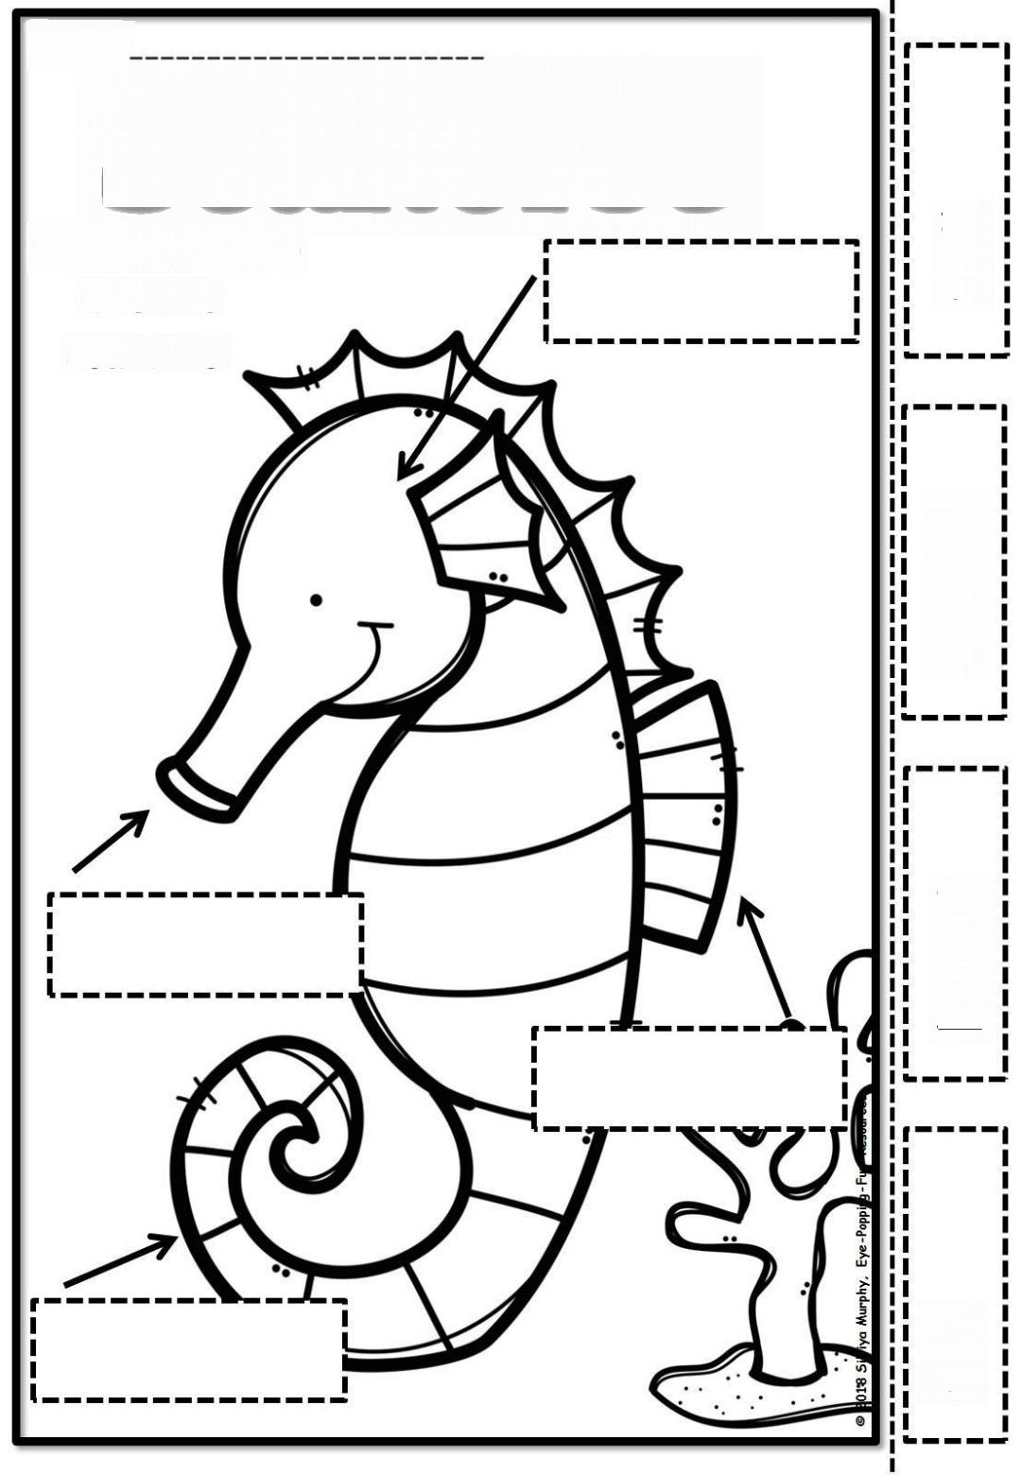**Label the Seahorse**

head

fin

curly tail

fin

snout

fin

fin

fin

Write 2 to 5 sentences to describe the seahorse.

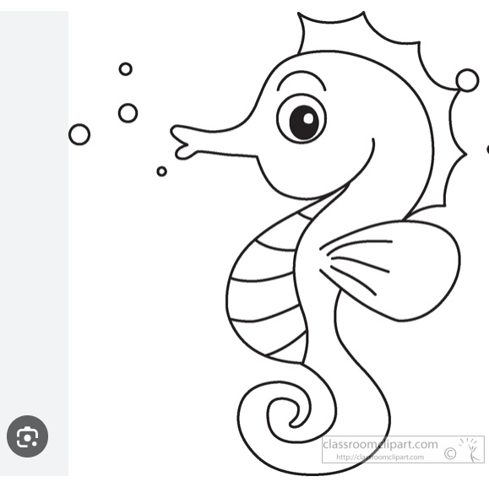

Model Answer

1. Blue
2. Camouflage
3. False
4. True
5. In the Pouch
6. They swim free.
7. Blue
8. Sight (c)
9. Free (c)
10. Eggs

Grammar

1. Noun: Ocean, seahorses, pouch, eggs, sea, tail, skin
2. Verb: Use, blend, swim.
3. Adjective: blue, quite, colours, curly, scaly free.
4. Oceans’
5. Pouches
6. Used
7. Blended
8. Right
9. Free

# **Rhyming Poem Space**

Up in the sky,

an astronaut so brave, in a shiny space suit,

ready to pave the way.

A spaceship awaits for the journey's start,

to meet friendly aliens, exploring worlds apart.

"3, 2, 1, blast off!" they cheer,

zooming through space, with no hint of fear.

Safe travels in the galaxy, where wonders never cease,

in the rhyming poem space, they find their peace.

Fill in the missing words

1. Up in the -------------,
2. An ----------------- so

brave, in a shiny ----------

-----------------, ready to pave the way.

Answer the following Questions

1. What is the astronaut wearing ?
2. What is the astronaut ready to do?
3. Where is the spaceship waiting to go?

___________________

1. Who or what is the spaceship going to meet?

True or False

1. The astronaut is smart. True or False?
2. The spaceship is waiting for the journey's start. True or False?
3. The astronaut feels scared while zooming through space. True or False?
4. What is the countdown heard before the spaceship takes off?  
   A) 5, 4, 3  
   B) 2, 1, 0  
   C) 3, 2, 1

Find the following from the poem:

1. A Noun ----------------
2. A Verb -----------------
3. An Adjective --------------
4. Circle all the plural nouns with “s”.

Add “ed” to the following verbs:

1. Pave --------------
2. Await ---------------

Write words that rhyme with:

1. Start, --------------
2. Cheer, ---------------

Write the following words in sentences

1. Astronaut;
2. Spaceship:

Write 2 to 5 sentences to describe the alien.

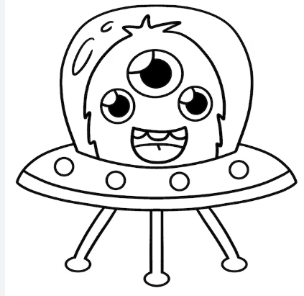

Model Answer

1. Sky
2. Astronaut, spaceship
3. A shiny space suit
4. To pave the way
5. Exploring worlds apart
6. Friendly aliens
7. False
8. True
9. False
10. 3, 2, 1 (B)

Grammar

1. Noun: sky, astronaut, spacesuit, spaceship, aliens, worlds, space, galaxy, poem.
2. Verb: pave, awaits, start, meet, exploring, cheer, blast off, zooming, travels, cease, find.
3. Adjective: brave, shiny, friendly, fear, safe.
4. Nouns with “s”

Aliens, worlds, wonders

1. Paved
2. Awaited
3. Apart
4. Fear

# **Rhyming Poem: The Moon**

In the sky so high,

the Moon shines so shiny, so bright,  
On a gloomy night,

it's a beautiful sight.  
It looks so large,

yet it's quite tiny,  
A magical orb, glowing divinely.

Fill in the missing words

1. In the ---------------- so high.
2. The ------------- shines so shiny, so bright.
3. A magical orb, ----------divinely.

True or False

1. The Moon is shiny and bright. (True/False)
2. The Moon appears large but is actually tiny. (True/False)
3. The Moon is a dull orb. (True/False)
4. The Moon is so low in the sky. (True/False)
5. What is the setting of the poem "In the sky so high"?  
   A) The ocean  
   B) A meadow  
   C) The sky  
   D) A forest
6. What does the Moon look like?  
   A) Rusty and old  
   B) Small and dull  
   C) Shiny and bright
7. What word is used to describe the Moon as being both large and tiny?  
   A) Massive  
   B) Gigantic  
   C) Humongous  
   D) Orb

Find the following from the sentence.

On a gloomy night,

it's a beautiful sight.  
It looks so large,

yet it's quite tiny

1. A Noun -----------------
2. A Verb ----------------
3. An Adjective ----------

Grammar

Add “s” or “es” to the following nouns:

1. Night -----------------
2. Orb --------------------

Add “ed” to the following verbs.

1. Shine ------------
2. Look -------------
3. Glow --------------

Find the words that rhyme with

1. Bright, ---------------,

--------------, ------------

1. Shiny, -----------------
2. Circle the following words in the poem

|  |  |
| --- | --- |
| Gloomy | large |
| Tiny | shiny |

Write the following words in a sentence.

1. Gloomy;
2. Shiny:

Write 2 to 5 Sentences to describe the Moon.

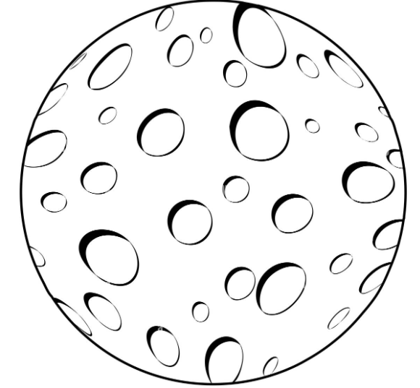

Model Answer.

1. Sky
2. Moon
3. Glowing
4. True
5. True
6. False
7. False
8. The sky (c)
9. Shiny and bright (c)
10. Orb (d)
11. Night, sight
12. Looks
13. Gloomy,beautiful, large, tiny
14. Nights
15. Orbs
16. Shined
17. Looked
18. Glowed

# **Rhyming Poem Stars**

In the sky up high,

stars so bright twinkle in the night,

each a sparkling light.

A shiny shooting star darts across the vast darkness,

leaving behind a trail of wonder and brightness.

Twinkling in the vast expanse, (space)

these space gems make the night sky dance.

Answer the following Questions

1. What is twinkling in the night sky?

--------------------------------------------------------------------------------------

1. How does the shooting star move through the darkness?

------------------------------------------------------------------------------------------------------------------------

1. What do the "space gems" do in the night sky?

--------------------------------------------------------------------------------------------------------------------

True or False.

1. The stars are dull and dim. (True/False)
2. Shooting stars always leave a trail of brightness behind them. (True/False)

Choose the correct answer.

1. What is "twinkling in the night" ?

A) Sun

B) Stars

C) Moon

1. What leaves behind a "trail of wonder and brightness"?

A) Shooting star

B) Moon

C) Sun

8. How do the stars look like at night?

A) Dim

B) Sparkling

C) Dull

Fill in the missing words from the poem

Fill in the missing words from the poem.

1. In the sky up high,

stars so bright ------------

in the night.

1. A shiny ---------------

----------------- darts

across the vast darkness.

Find the following from the sentence.

In the sky up high, stars so bright twinkle in the night,

1. A Noun ---------------
2. A Verb ---------------
3. An Adjective

Add “s” or “es” to the following nouns

1. Light ----------------
2. Star ----------------
3. Expanse -------------

Add “ed” to the following words.

1. Twinkle ------------
2. Sparkle ------------
3. Dart --------------
4. Dance -------------

Write the following words in a sentence.

1. Sparkling
2. Shiny

Write 2 to 5 sentences to describe the star.



Model Answer

1. Stars so bright
2. Darts
3. Dance
4. False
5. False
6. Stars (b)
7. Shooting star (a)
8. Sparkling (b)
9. Twinkling
10. Shooting star
11. Sky, stars
12. Twinkle
13. High, bright
14. Lights
15. Stars
16. Expanses
17. Twinkled
18. Sparkled
19. Darted
20. Danced

Rhyming Poem

Mice

I think mice

Are rather nice.

Their tails are long,

Their faces small,

They haven’t any

Chins at all.

Their ears are pink,

Their teeth are white,

They run about

The house at night

They nibble things

They shouldn’t touch

And no one seems

To like them much.

But I think mice

Are nice.

True or False

1. Mice have long tails, small faces, and no chins at all (True/False)
2. Mice have white ears and pink teeth. (True/False)
3. Mice have short tails. (True/False)
4. Everyone seems to like mice. (True/False)

Choose the correct answer.

1. What colour are the mice ears
2. Pink
3. Brown
4. White
5. When do the mice run about the house?
6. During the day.
7. In the morning
8. At night

Fill in the missing words from the poem.

1. I think -------------- are rather nice.
2. They ------------- things. They shouldn’t touch.
3. What colour are the mice ears and teeth?

Read the sentence and find the following;

Their ears are pink,

Their teeth are white,

They run about

The house at night.

1. Noun -------------------
2. Verb -------------------
3. Adjective. -------------
4. Circle or the nouns with “s” or “es”

Add “ed” to the following verbs.

1. Nibble ----------------
2. Touch ----------------
3. Seem ------------------

Write the rhyming words from the poem.

1. Mice, --------------
2. Small, --------------
3. Touch, -------------
4. White --------------

Write the following words in sentences.

1. House:

-------------------------------------------------------------------------------------------------------------------

1. Chins:

--------------------------------------------------------------------------------------------------------------------

Write 2 to 5 sentences to describe the mouse.

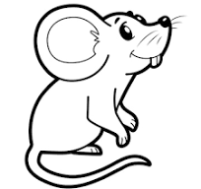

Model Answer

1. True
2. False
3. False
4. False
5. Pink (a)
6. At night (c)
7. Mice
8. Nibble
9. Pink ears and white teeth.
10. Ears, teeth, house
11. Run
12. Pink, white, night
13. Tails, faces, chins, ears
14. Nibbled
15. Touched
16. Seemed
17. Nice
18. All
19. Much
20. Night