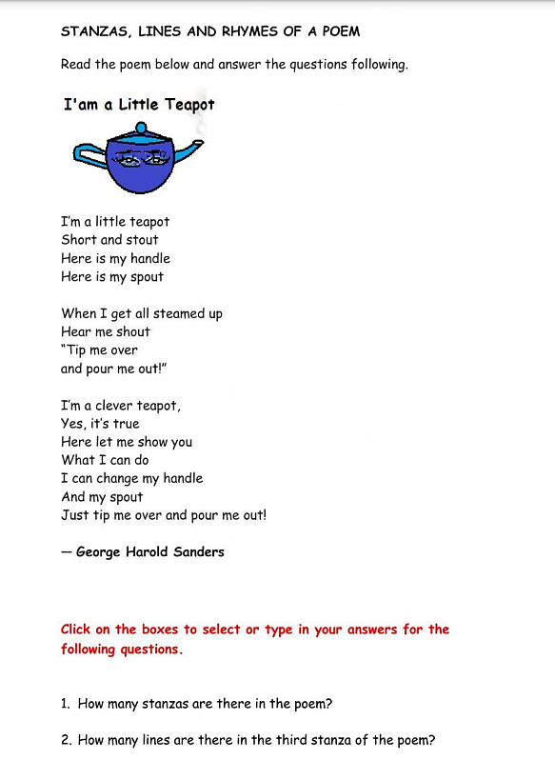

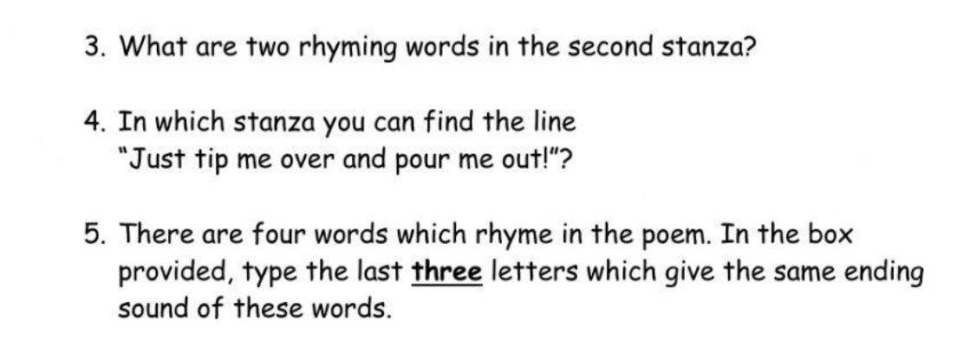

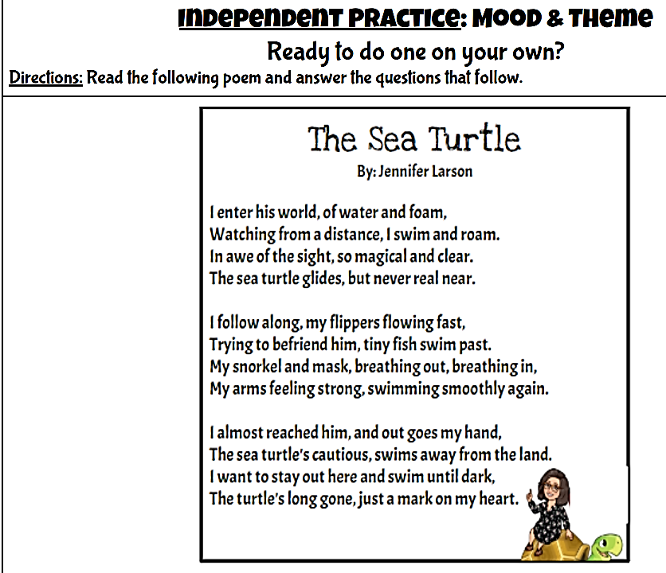



3. Who is the author?

4. What is the title of the poem?

5.How many lines are there?

6.Can you find 4 different rhyming words?

7.Can you write the first line in the second stanza?

8.Can you write the third line in the third stanza?

9. Can you find another word for “small” in the second stanza?

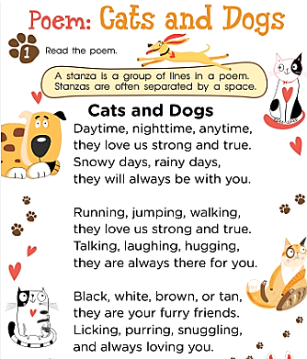



3. What is the title of the poem?

4.How many lines are there?

5.Can you find 4 different rhyming words?

6.Can you write the first line in the second stanza?

7.Can you write the third line in the third stanza?

8. Can you find another word for “real” in the second stanza?

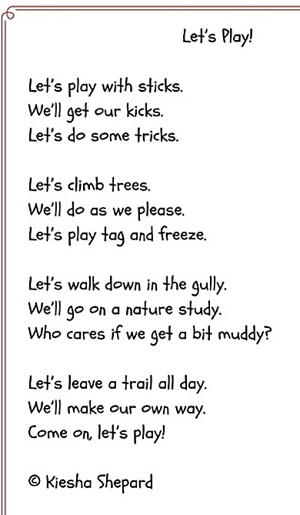



3. What are the repetition sentence or words?

4. What is the title of the poem?

5.How many lines are there?

6.Can you find 4 different rhyming words?

7.Can you write the first line in the second stanza?

8.Can you write the third line in the third stanza?

9. Can you find another word for “real” in the second stanza?