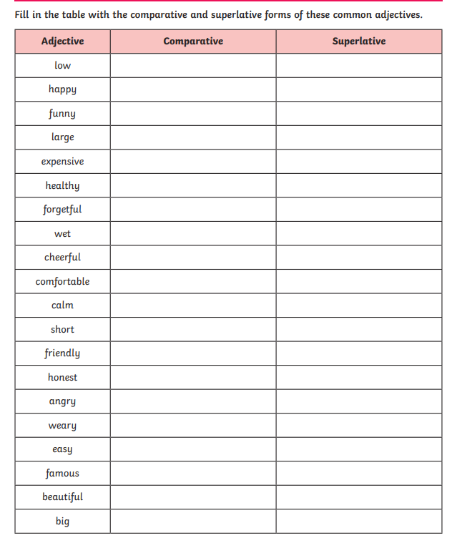

**Vocabulary Words Included: easier, more difficult, the most expensive, the biggest, shorter, more famous, the most cheerful, healthier, largest, happiest, more comfortable, the most comfortable**

School is a place where we go to learn new things every day. Some subjects may be easier for us to understand, while others might be more difficult, but with practice, we can improve. In school, we use pencils, notebooks, and even computers for our lessons. The library at school has the most expensive books, full of exciting stories and information about the world. Our school building is the biggest one in our town, with many classrooms and a big playground where we can play and have fun. During lunchtime, we get to choose from different meals, some shorter like sandwiches and others healthier like salads. Our school has a gym where we play sports and exercise to stay strong and fit. In our school play, we act out stories and become more famous among our friends and families. The teachers always have the most cheerful smiles, making us feel happy and safe. Our schoolyard has the largest trees where we can sit and read, making us feel the happiest. In our classrooms, we use desks and chairs that are more comfortable for us to sit and learn. During art class, we create the most comfortable masterpieces, expressing ourselves in creative ways.

1-Highlight all the comparative and superlative adjectives in the text

2-Write 3 comparative sentences from the text:

______________________________________________________________

3- Write 3 superlative sentences from the text:

_____________________________________________________________

_____________________________________________________________

_____________________________________________________________

4- Write a sentence for each word:

The most adorable

______________________________________________________________

The Greatest:

______________________________________________________________

Easier than:

_____________________________________________________________

More difficult than

_____________________________________________________________

Easier than and the easiest

______________________________________________________________

More comfortable than and the most comfortable

______________________________________________________________