**Aspire International School  
Year 8 – Class ________**

**Name: _______________________ Date: ___________**



**Text A** *Anarche and the weaving contest*

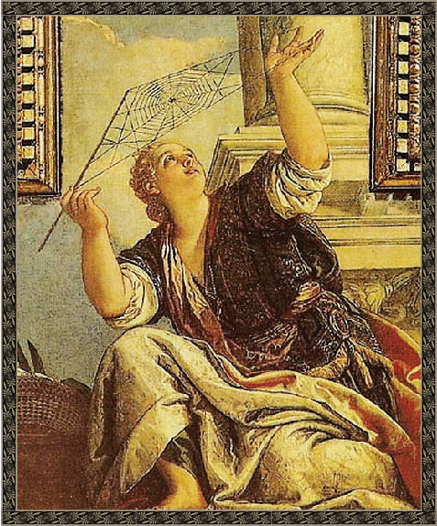Directions: Read the following passage and answer the questions that follow. Refer to the text to check your answers when appropriate.  
Arachne and the Weaving Contest *is a story from Greek mythology. Greek myths often explain the origin of something in the natural world through stories about the many deities, heroes, and mythological creatures that were part of ancient Greek culture. This myth features Athena, the Greek goddess of wisdom and crafts, who was viewed as intelligent, athletic, talented, and also incredibly vain.*

*Mortals that* ***provoked*** *her often had unhappy endings to their stories.*

Long ago, there was a mortal woman named Arachne who was famous for her weaving.

People from all over would come to watch her nimble and graceful fingers flicker across the cloth as she wove her beautiful fabrics. All the attention and praise for her hard work eventually made Arachne quite **conceited**. One day, she bragged that her weaving was better than that of the goddess Athena.

By and by, Athena heard about Arachne’s boast. So, disguised as an old woman, Athena went to Arachne’s home. “You should not compare yourself to the gods,” the old woman warned. “If you apologize, Athena might let you live.”

“Ha!” snorted Arachne. “If Athena thinks she can compete with me, she is sadly mistaken. I dare her to try to match the magnificence of my work. Everyone knows I am the best weaver that ever lived.” Upon hearing Arachne’s challenge, Athena let her disguise melt away and the goddess stood, glowering, in front of Arachne.

“I accept your challenge,” Athena stated **imperiously**, “but the loser must agree to never weave on a loom or touch a spindle again.” Arachne’s face reddened for just a moment, but she nodded, still holding to her foolish pride. The women sat down at their looms and began to weave, and a crowd gathered to watch the contest. All day, the hands of the mortal and the goddess danced across the looms.

By the time the sun began to set over the mountains, it was clear that Arachne’s cloth was glorious. To insult and mock Athena, she had woven a gorgeous tapestry showing the gods punishing mortals who defied or dishonored them.

Although stunning and flawless, Arachne’s tapestry could not compare to Athena’s. The goddess had woven dazzling images of the gods in all their glory, dressed in exquisite colors that human eyes had never beheld. The sparkling waves seemed to ripple across the fine gossamer cloth; the sun’s rays looked so real that those standing close could actually feel the warmth of sunbeams radiating from the fabric.

Arachne hung her head. Although her pictures were beautiful, they were not as realistic as Athena’s. The goddess was the obvious winner of the contest.

Tears filled Arachne’s eyes as she imagined the life before her, never being able to touch a loom or spindle again.

Athena herself was amazed at Arachne’s talent. Not even her wrath at the girl’s impertinence could wholly overcome her wonder. For an instant, she stood entranced; then she touched Arachne’s forehead with her spindle.

“Weave on, Arachne,” she said. “Since it is your glory to weave, you and yours must weave forever.”

In that moment, Arachne’s human form shrank to that of the very first spider, and so remained. As a spider, she spent all her days weaving and spinning, and even now you may still see her handiwork among the rafters.

After reading the above text, answer the questions below:

1. What is the theme of this myth?

a. Cheaters never prosper.

b. Slow and steady wins the race.

c. Hard work always brings a reward.

d. Vanity can lead to trouble.

2. What details from the story help to convey this theme?

______________________________________________________________________________________________________________________________________________________

3. What is the conflict type featured in this myth ? Tick one box.

character vs. character

character vs. nature

character vs. society

character vs. self

4. Circle three words that best describe Arachne as she is characterized in the myth.

talented loyal overconfident

wise athletic humble hardworking

curious loyal humble

Curious talented athletic

5. How does Arachne react to the old woman’s warning? How does her reaction affect   
the rest of the story?

__________________________________________________________________________________________________________________________________________

6. In your opinion, was Arachne’s ultimate punishment appropriate? Why or why not?

__________________________________________________________________________________________________________________________________________

7. Draw a line to match each word from the text to its synonym.

provoked arrogantly

wholly smug

conceited angered

gossamer completely

imperiously disrespect

impertinence silky

8. Fill in the chart below with similarities and differences between Arachne and Athena.

|  |  |
| --- | --- |
| Similarities | Differences |
| ___________________________________ | ___________________________________ |
| ___________________________________ | ____________________________________ |
| __________________________________ | ____________________________________ |

9. According to the above text , write three features of a mythical narrative:  
 1. ___________________________________________________________________

2. ___________________________________________________________________ 3. ___________________________________________________________________

**Text B   
 The Number of Endangered Species In Canada Growing**

By Monique Conrod

The number of *endangered species* in Canada is growing. Five new animal species and five types of plants were declared endangered in November by a committee of wildlife experts.

Beluga whales from the St. Lawrence Estuary, Atlantic Gaspésie caribou, Townsend’s moles, as well as a species of butterfly and a snail are the latest animals to become endangered in Canada.

Another species – the Eastern box turtle – was declared to be *extirpated*. (Extirpated means a species is no longer found within a particular region, but it still exists in other areas.)

The Committee on the Status of Endangered Wildlife in Canada (COSEWIC) meets once a year to consider new species that might be “at risk” of becoming endangered, and to review species that have already been declared at risk.

They look at whether the population of a species is increasing or decreasing, and at how much of its natural habitat is left. If they think a species is in trouble, they ask the government to put it on a list called the Species at Risk Act (SARA) so it can be protected.

There are different levels of risk on the list. The lowest level is “special concern,” followed by threatened, endangered, extirpated and extinct.

Once a species is listed under SARA, it is against the law for people to harm or kill members of the species. It is also against the law to destroy the species’ “critical habitat.” Critical habitat is the area where a species lives and the physical features it needs in order to find food and shelter, and to breed and raise its young.

However, species recommended by COSEWIC are not automatically added to the SARA list. It is up to Canada’s Minister of the Environment and the federal government to decide if a species should be declared officially at risk.

Some people feel it takes the government too long to decide. Since 2011, 67 species have been recommended for the list, but the government has not made a decision about any of them yet. Some species are never added to the list because it would be too expensive to protect their habitats.

A group of Canadian scientists recently studied whether or not SARA is helping to protect wildlife. They looked at 369 species of animals that have been on the SARA list for 10 years or more.

They found that the level of risk had gotten worse for 115 species. Only 20 species had improved enough to be considered no longer at risk.

The scientists also found that critical habitat had been identified and protected for less than half of the species listed under SARA.

For example, COSEWIC identified the beluga whale as “threatened” 10 years ago. The whale’s critical habitat was identified two years ago, but the government has not taken action to protect it. Factors like industrial developments, pollution, toxic algal blooms and noise disturbance are all hurting the beluga whale’s habitat.

Loss of habitat is one of the leading causes of extinction. The scientists say the federal government needs to do more to identify and protect the habitats of species at risk.

1. “The number of *endangered species* in Canada is growing.” Give examples from the passage to prove that statement.  
______________________________________________________________________________________________________________________________[1]

2. “Another species – the Eastern box turtle – was declared to be *extirpated*. (Extirpated means a species is no longer found within a particular region, but it still exists in other areas.)”

**(a)** Why have brackets and dashes been used in these phrases?  
_____________________________________________________________ [1]

**(b)** What effect does the writer achieve by using dashes instead of brackets?  
_____________________________________________________________ [1]

3. What does the word “COSEWIC” stand for?  
________________________________________________________________________ [1]

4.What does the government do to protect the endangered species. Give two points.  
  
 1. _________________________________________________________________

2 ________________________________________________________________ [2]

5. Who decides that a certain species is endangered?  
_______________________________________________________________________ [1]

6. “species have been recommended for the list” What is the function of using passive voice   
 in that statement?

­­­______________________________________________________________________ [1]

7. Scan the text and find one word to mean “animals at risk.

­­­­­­­­­­­­­­­­­­­­­_______________________________________________________________________ [1]

8. In your own words explain the problem of the beluga wale .  
________________________________________________________________________ [1]

9. Give an example of a reported speech.

________________________________________________________________________ [1]

10. Find a linking word of contrast.

________________________________________________________________________ [1]

11. What is the recommendation mentioned at the end of the text?

___________________________________________________________________________________________________________________________________________________ [2]

12. What is genre the text?

Tick one box.

a recount

a biography

an information report

a diary entry [1]

13. Write two features of that genre.  
______________________________________________________________________________________________________________________________________   
_________________________________________________________________ [1]

Text C

Hi Ravi,

Thanks for your email. So you’re doing the Ancient Greeks this term? We did it last term and in my opinion it’s the best project ever. I’m sure you’ll love doing the Myths and Legends. My favourite is Theseus and the Minotaur, but King Midas is OK too. Can you imagine what it would be like if you were like King Midas and everything you touched turned to gold? I can see that you wouldn’t want to be him for long, but just for a short while it’d be amazing. Think how rich you’d be! You could turn all the things you really hate - like vegetables - into gold and swap them for all the things you do want.

Here’s part of what I found out about the Greeks and wrote in my project book:

Most of what we know about Ancient Greek myths comes from one of two sources: ancient texts and paintings on vases. Although little remains of any other form of Greek art, over 100000 pots and vases exist in museums today.

When we were doing the Ancient Greeks we went to visit a museum and we were allowed to touch a piece of a pot. It was only a small piece but somebody had stored oil in it over 2000 years ago. Isn’t that amazing?

The worst thing about Ancient Greece, I’m sure you’ll agree with me, was the slaves. Here’s another bit from my project book:

Between a quarter and a third of Athens’ 300 000 population were slaves. These were men and women captured in wars or born into slavery.

Many slaves had special skills, such as nursing and teaching, while others had the hardest and most unpleasant work to do. It was common for a rich household to have many slaves. Some slaves were owned by the state. For example, archers from Scythia were used as a kind of police force by the Athenian government.

Can you believe that there were 100 000 slaves living in one small city? Life for some of them must have been dreadful.

I really hope you enjoy this project. For me, it’s one of the most exciting ones we’ve ever done - but you know how much I love history. Email me to tell me what you’re doing and I’ll tell you what I found out too.

Your friend,

Benji

1. What is Ravi studying at school this term?  
   ________________________________________________________ [1]
2. Did Benji enjoy studying the Greeks? Find evidence in the text to support your answer.  
   __________________________________________________________________________________________________________________ [2]
3. Tick (✓) two things about King Midas that you learn from the email.

Everything King Midas touched turned to gold.

King Midas had slaves.

King Midas hated vegetables.

There is a Greek myth about King Midas.

We know about King Midas because of paintings on pots.

1. Benji’s email includes both facts and opinions. Tick (✓) the boxes to show whether these statements are fact or opinion.

|  |  |  |
| --- | --- | --- |
| Statement | Fact | Opinion |
| It was only a small piece but somebody had stored oil in it over 2000 years ago. |  |  |
| The worst thing about Ancient Greece,  I’m sure you’ll agree with me, was the slaves. |  |  |
| Between a quarter and a third of Athens’ population were slaves. |  |  |
| My favourite is Theseus and the Minotaur, but King Midas is OK too. |  |  |

1. Benji wants his friend to enjoy studying the Ancient Greeks. Write an   
    example of persuasive language from the email. [1]  
     
   ______________________________________________________________________________________________________________________
2. Reread this part of the email where Benji is quoting from his school project on the Ancient Greeks:

Most of what we know about Ancient Greek myths comes from one of two sources: ancient texts and paintings on vases. Although little remains of any other form of Greek art, over 100 000 pots and vases exist in museums today.

What is the purpose of this text? Underline the best answer.

To persuade   
 To inform   
To entertain   
To argue   
To show [1]

1. Benji talks about three different parts of his project on the Ancient Greeks. What are they? (The first one is written for you.)

1 Greek Myths and Legends   
2 _________________________________________________________  
3 ________________________________________________________ [1]

8. Find from the text an example of the following:  
 a. Conditional sentence ________________________________________  
 b. Linking word of contrast ____________________________________  
 c. A sentence with a modal verb _________________________________  
 d. Superlative degree adjective _______________________________ [2]

9. “Most of what we know about Ancient Greek myths comes from one of two sources: ancient texts and paintings on vases.” What is the function of the colon in that sentence.  
______________________________________________________________[1]

10. “You could turn all the things you really hate - like vegetables - into gold   
 and swap them for all the things you do want.” What is the function of the   
 dashes in that sentence?  
_____________________________________________________________ [1]

11. Reread the extracts from Benji’s project book. Tick (✓) two features of   
 historical report text which you can find in this email.

Explains something

Gives information

Informal language

Written in the first person

Written in the past tense [1]

12. Write one sentence from the text which is auto-biographical. [1]  
 __________________________________________________________

13. Draw lines to match the sentence from the email with each of these   
different text types. [2]

Sentence Text type

|  |  |
| --- | --- |
| Isn’t that amazing? | Recount |
| You’ll love doing the Myths and Legends. | Report |
| Some slaves were owned by the state. | Persuasion |
| When we were doing the Greeks we went to visit a museum. | Informal chat |

[2]

Writing

Write a letter to a friend. Tell them about a school project you enjoyed working on and try to persuade them to enjoy it too.

Your letter should:

* + Give some information about the subject.
  + Tell your friend why you enjoyed the subject.
  + Try to persuade your friend to enjoy studying the same subject.
  + Use full English forms of words rather than contracted forms you may use for texting friends.

When you are planning your letter, think about:

* + The subject you are going to write about. You need to remember some interesting facts about it.
  + The order in which you will introduce your ideas.
  + Which text types you are going to use. You may need to use more than one.
  + Whether your friend already knows something about the subject.
  + How you can make your letter really interesting for your friend to read.

**Grammar Revision:**



A. Label: simile, metaphor, hyperbole, or personification. Explain.

Example: I wish you and your brother wouldn’t fight like cats and dogs.

Simile Comparison made using like or as.

___________________________________________________

1. The old couch springs moaned as the rather large man sat down on it.  
 ___________________________________________________________

2. The hot sauce burned like fire when I bit into the taco.  
 ___________________________________________________________

3. I am so tired, yet I still have a million things to do before bed.  
 ___________________________________________________________

4. You can’t find your book because your room is a pig pen. Please clean it.  
 ___________________________________________________________

5. The piece of chocolate cake taunted me each time I went to the kitchen.  
 ___________________________________________________________

6. The neglected little kitten was as light as a feather from having no food.  
 ___________________________________________________________

B. Determine if the underlined phrase is an idiom, simile, or metaphor.

Idiom – a common expression which means something different than what the words literally mean. Ex: once in a blue moon

***Simile*** *– compares two unlike items using like or as. Ex: white as snow* ***Metaphor*** *– compares without using like or as. Ex: heart of stone*

1. I wish I had remembered my umbrella. It has rained cats and dogs all day.

idiom simile metaphor

1. When I went outside this morning, the front yard was beautiful. The dew drops were sparkling like diamonds in the early morning sun.

Idiom simile metaphor

1. When Betty learned that she had won the grand prize, she was on cloud nine.   
    idiom simile metaphor
2. That assignment was a breeze. I finished it in less than an hour.  
   idiom simile metaphor
3. You know my hands are tied, making it impossible for me to tell you what was said.   
   idiom simile metaphor
4. Larry was such a hog last night at supper. It’s no wonder he had a stomach ache.   
   idiom simile metaphor
5. You need to think before you speak. Every time you are around her, you put your foot in your mouth.

idiom simile metaphor

1. The fluffy pillows that mom bought were as soft as a cloud.

idiom simile metaphor

1. **Joining Clauses at the Circus**

**Coordinating Conjunctions:** for, and, nor, but, or, yet, so

**Subordinating Conjunctions**: after, although, as, because, before, even if, if, now that, once, since, that, though, unless, until, when, whenever, where, wherever, while.

1. The circus came to town. Tickets were cheap. I decided to go with my friend.

_______________________________________________________________________________________________________________________________________________________________________________________________.

2. A guy stuck his head in the lion’s mouth. Bears were dancing in tutus. An elephant rode a bike.

________________________________________________________________________________________________________________________________

3. My belly hurt from eating junk. I had a good time. The circus is always fun.

________________________________________________________________________________________________________________________________

1. **Underline the correct transition word in the following sentences.**

1. (Because, Before) it was raining, I didn’t walk my dog this evening.

2. I love chocolate, (although, so) I eat chocolate candy whenever I can.

3. The test was really hard. (Therefore, Then), only five students passed it.

4. First, you have to answer the questions. (Next, So), you hand in your paper.

5. Ben needs to go to bed early. (Although, Otherwise), he will be late for school.

6. You will see a big tree; (further on, however) you will see a fork in the road.

7. He really loves reading. (Despite, In fact), he reads almost all the time.

8. That would not be smart. (Despite, In other words), that would be idiotic.

9. (Over, Among) the trees of the forest, the deer ran gracefully.

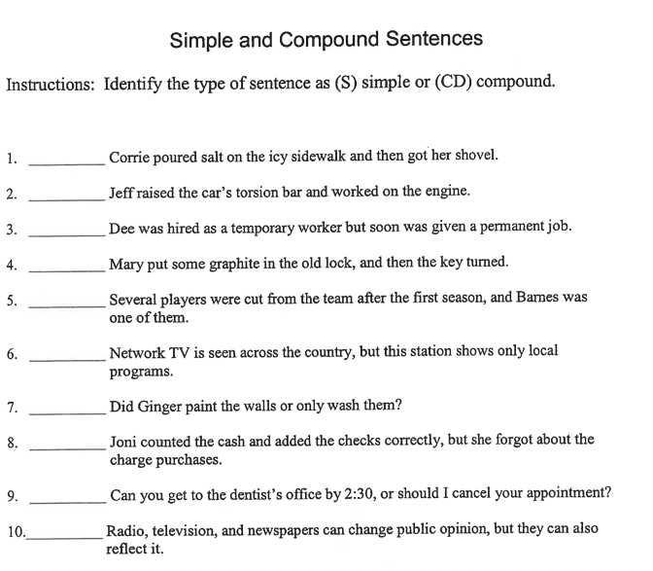10. You are always late. (On the other hand, Like), you can be trusted.

**E.**

1. **Insert necessary colons. Put a "C" in front of any sentence that is correct.**

1. All his thoughts were centered on one objective profit.

2. We may divide poems in to three classes narrative, lyric, and dramatic.

3. Three kinds of poems are narratives, lyrics, and dramas.

4. Within three hours we had a str4ange variety of weather rain, hail, sleet, and snow.

5. Promptly at 815 p.m. the minister began his sermon by quoting John 2021.

6. The conference had only one purpose agreement upon a suitable topic for a research paper.

7. The players shared one goal winning.

8. My roommate has a simple formula for looking like a sophomore act depressed.

9. He mentioned that the only interests he has are cars, sports, and cars.

10. I took the following courses last year history, math, geography, and speech.