**Name: ---------------------------------**

**Class: ----------------------------------**



Sea Animals

Read the text and answer the Questions.

Seals

Seals are **mammals** that live mostly in cold seas. A seal’s

body is round in the middle and narrower at the ends. The

**skin** is usually gray, brown, or black. Instead of legs seals

have two pairs of **flippers**. **Flippers** help seals to swim.

Seals eat mostly fish. Some also eat squid, and shrimps.

.Questions:

1. Seals are ---------------- that live in cold seas.
2. Birds b. fish c. mammals
3. Where do seals mostly live?

Cold seas

1. What does the seal’s body look like?

Round in the middle and narrower at the ends.

1. The seal’s skin is usually gray, brown,

and black.

1. Instead of legs what do seals have?
2. Fins b. flippers c. tails
3. How many flippers do seals have? Two pairs.
4. What do flippers do? Help seals to swim.
5. What do seals eat?

Fish, squid, shrimp

Answers could be any of the following:

1. Find a noun: seals, seas, mammals, body, skin, legs, flippers, fish, squid, shrimps.
2. Find a verb: live, help, swim, eat
3. Find an adjective: cold, round, narrower, gray, brown, black, two,
4. Underline the plural nouns with “s”.
5. Read the text and circle the following words in the text.

|  |  |  |
| --- | --- | --- |
| mammals | flippers | skin |

1. Write each word in a sentence.
2. Swim:-------------------------------------------------------
3. Eat: ------------------------------------------------------
4. Look at the picture and write 2 to 5 sentences to describe the seal.

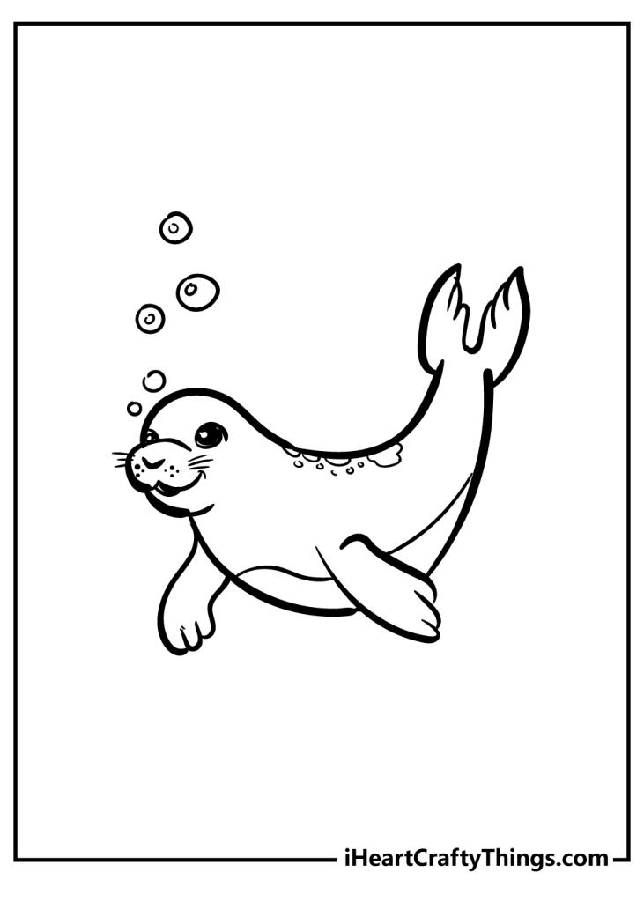

Marking Scheme Spelling CVC words /1

Capital Letters /2 Letter formation /1

Finger Spaces /2 Sentence structure /1

Full Stops /2 Descriptive words /1