

English



Weekly Pack

Year 2/Term 2

Week 7

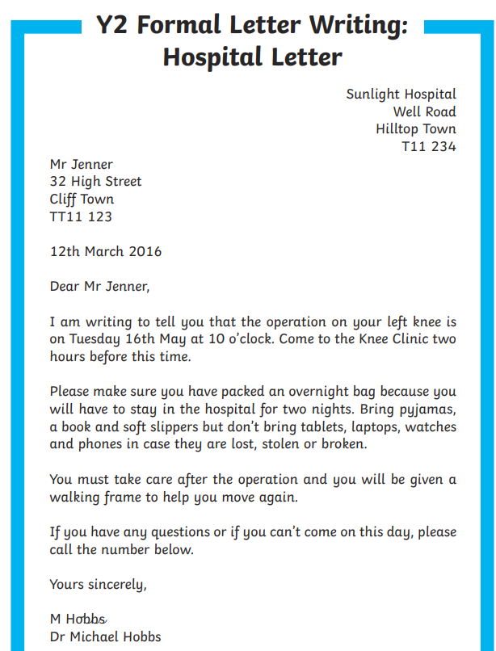

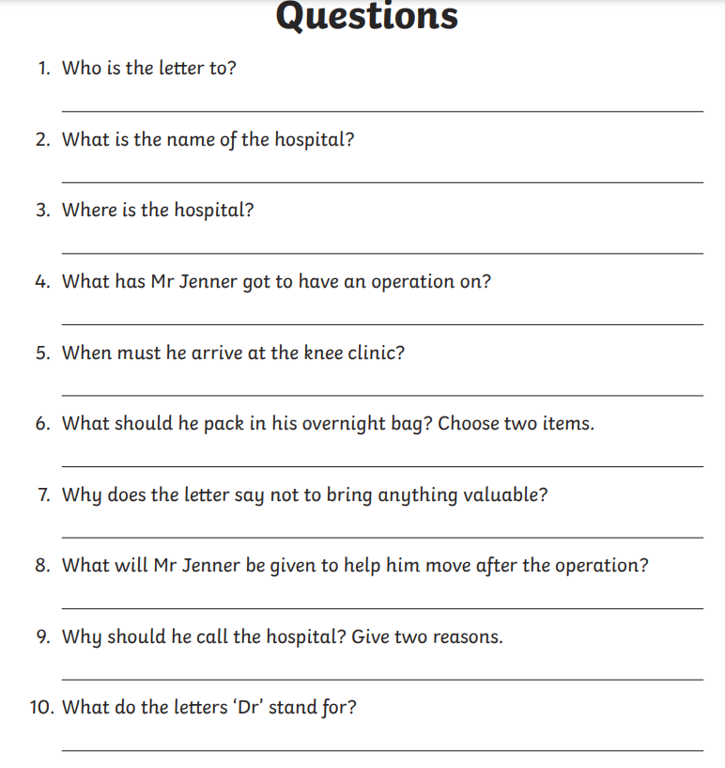

11- who is the recipient?

___________________________________________________

12-who is the sender?

___________________________________________________

13-what is the address of the sender?

___________________________________________________

14-what is the address of the recipient?

___________________________________________________

15-What kind is the letter, formal or informal?

___________________________________________________

16-what is the purpose of the letter?

___________________________________________________

17-what is another meaning for the word” faithfully” used in the letter?

__________________________________________________

18-what is the date that the letter has been sent?

__________________________________________________

19-find an antonym for the word “right” in the text

_________________________________________________

20-What he should do if he wants to ask more questions?

_________________________________________________

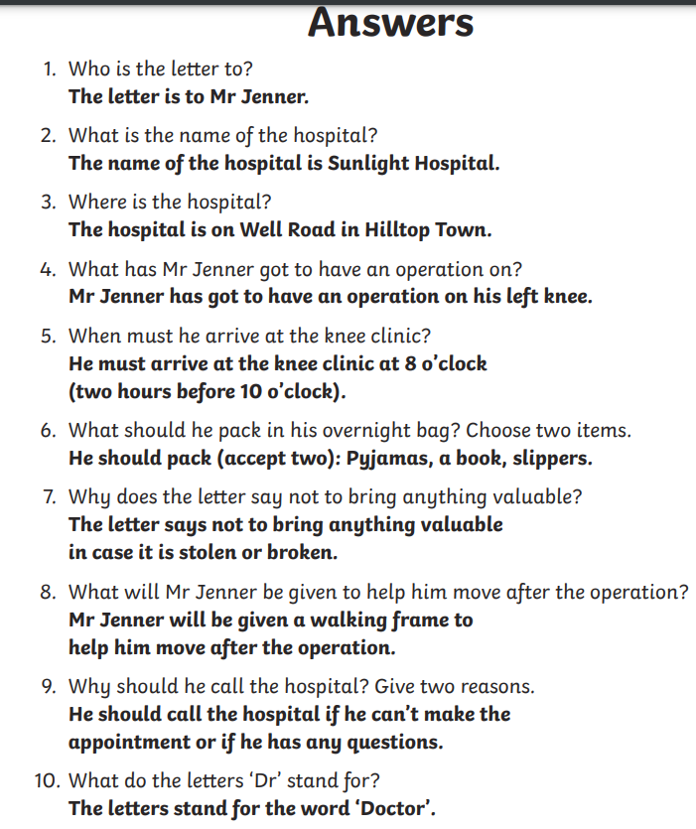

11- who is the recipient?

**__Mr Jenner**

12-who is the sender?

**__Dr Michael_____**

13-what is the address of the sender?

**______Sun light hospital**______________________

14-what is the address of the recipient?

_____**32 high street________________________**

15-What kind is the letter, formal or informal?

_____**formal letter**_________________________________

16-what is the purpose of the letter?

_____**To inform the patient of his operation day**________

17-what is another meaning for the word” faithfully” used in the letter?

_____**sincerely**______________________________________

18-what is the date that the letter has been sent?

_____**12th March 2016**_________________________

19-find an antonym for the word “right” in the text

**_____left__________________________________________**

20-What he should do if he wants to ask more questions?

_____**call on the phone number___________________**