Performance Assessment Task (Report)
Name: Wegdan Helmy Grade: 1
Subject: English, Math and Science

Task
-Children will do a project about Earth. This project should integrate the three subjects together; English, Math and Science.
-Each subject will meet some objectives and the children will be assessed according to these objectives.
-The project will be done in the classroom under the supervision of the teacher so she could assess them easily. Children will be asked to provide some materials and objects for their own project.

Objectives in Science:
- Talk about how some of the scientific knowledge and thinking now was different in the past.
- Make and use a physical model of Earth
- Create a poster to present the old thoughts that the Earth was flat, squared or people could fall off the edge of the Earth. The new and actual facts that Earth is spherecial or round. Giving evidence through pictures ofEarth from space.

Objectives in Math:

- Develop the skills of characterising and classifying properties of shapes.
- Investigate the properties of shapes and categorise shapes based on a variety of shape characteristics.
- Shapes can be linked to objects in Science (Earth)

Objectives in English:

- Non-fiction Fact Files Using Pictures and labels to write simple sentences about Earth
- Include some relevent information when writing simple non-fiction texts in familiar real-life contexts.

Requirement of your research report:
1. Have a title page with your name, class, date and title.
2. Your research should be divided into 3 parts, organized as follows:
- Introduction:
Introduce your concept and some basic information about it.
-What is Earth?
-Is it true that Earth is flat? Why?
-How is that scientists know the Earth is like a ball?

Body

Do the Earth Project.
Expalin how it was done.
Describe the Earth using scientific terms (planet, water, land)
Talk about materials used.

- Conclusion:
Write down 2 or 3 Facts about the Earth.
Describe Earth Using Terms 3D, Sphere, Curved face, no edges.

Rubrics of the project
Criteria | 1 | 2 | 3 | 4
Science | The student demonstrates limited understanding of the Earth and its features, processes, and interactions. | The student attempts to communicate their understanding of the Earth, but vocabulary and explanations are limited or unclear. | The student demonstrates a good understanding of the Earth, including its features, processes, and interactions. | The student demonstrates a deep understanding of the Earth, including its features, processes, and interactions.
Math | Cannot identify or draw spheres accurately. | Can sometimes identify and draw spheres, but struggles with accuracy in orientation and size. | Can identify and mostly draw spheres in various orientations and sizes. | Can confidently identify and correctly draw spheres in various orientations and sizes..
English | Illustrations support and enhance the text, providing additional visual information about the shape of the Earth. | The text demonstrates good use of grade-appropriate vocabulary and language structures. Sentences are mostly clear and varied. | The text demonstrates some use of grade-appropriate vocabulary and language structures, but there may be some errors or lack of variety in sentence structure | The text includes accurate and detailed information about the shape of the Earth

Materials needed for the project for each child
Subject | Example | Materials needed
Science | 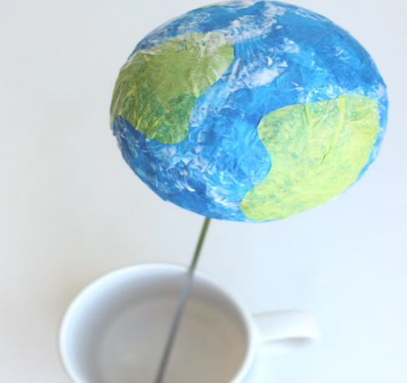 | - Sphere styrofoam (Samir and Ali Staitionary) medium size.  - blue crepe paper  - green crepe paper  - bottle of white school glue  Shish Tawook Sticks

