Year 2 Midterm Revision pack

Maths

October 2023

**Name: ______________________**

**Class: _______________________**

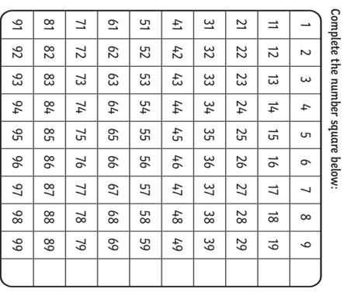a)**Complete the missing numbers in the 100 square chart:**

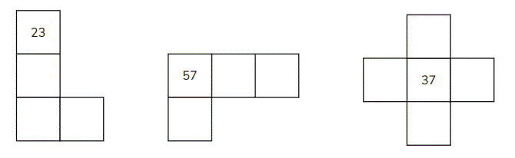b) **Complete the following 100 square missing number patterns:**

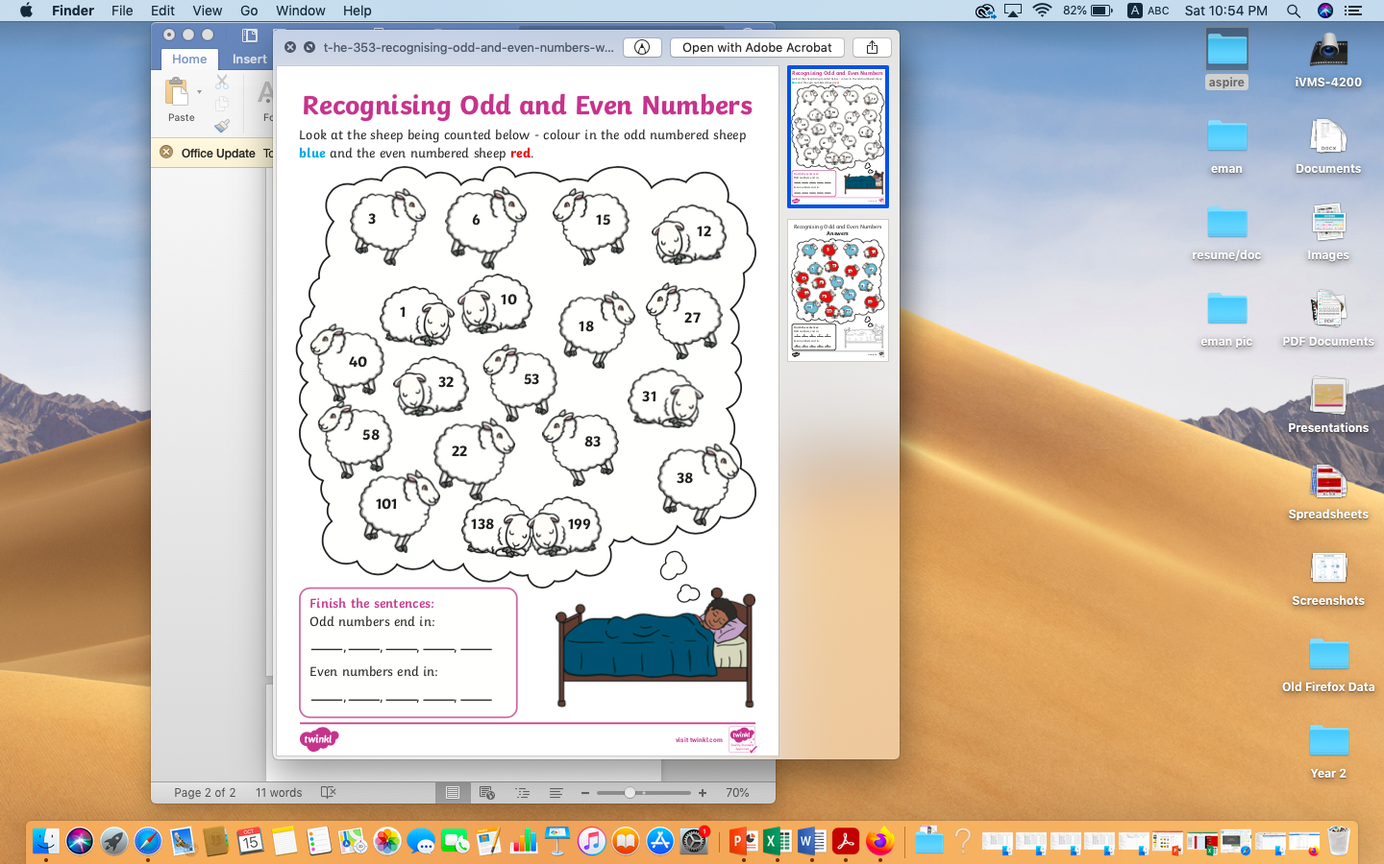

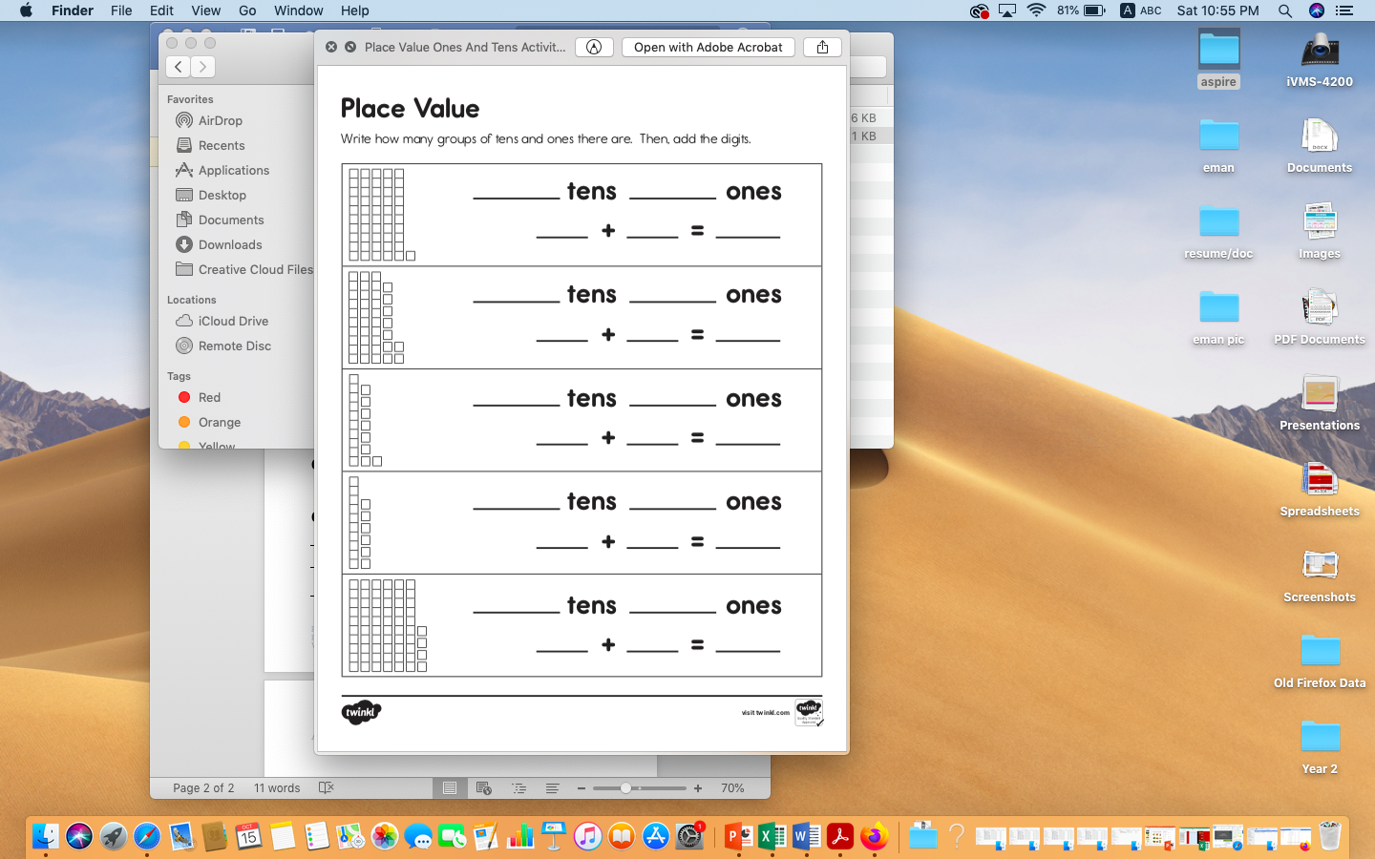

**Find the following numbers on the number line:**

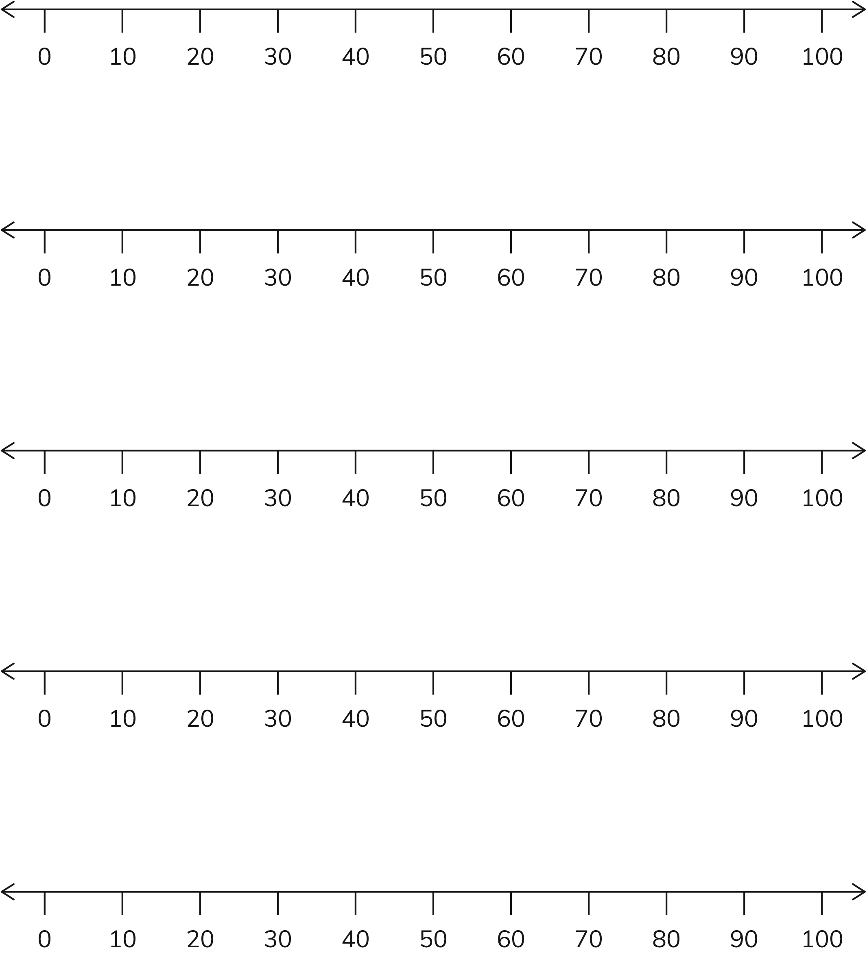





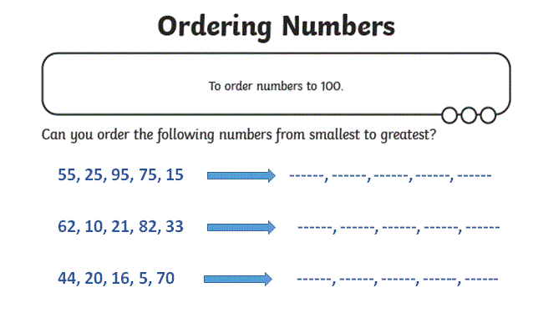

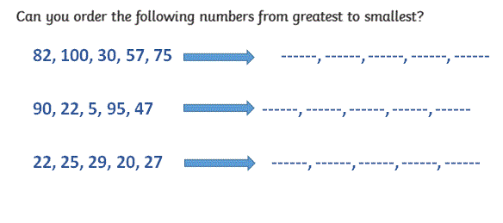



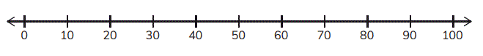 **Row addition and subtraction**

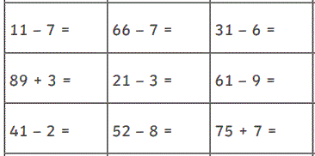

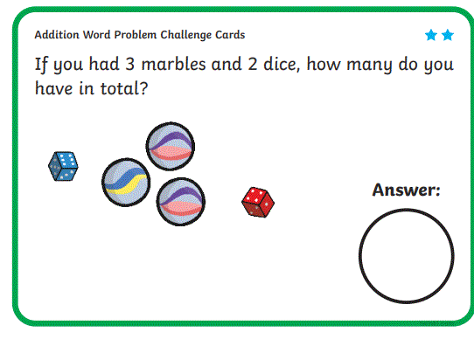**Find the sum of each word problem, write the number sentence:**

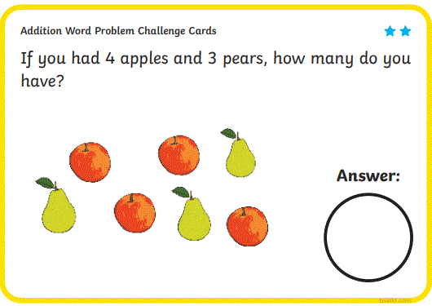

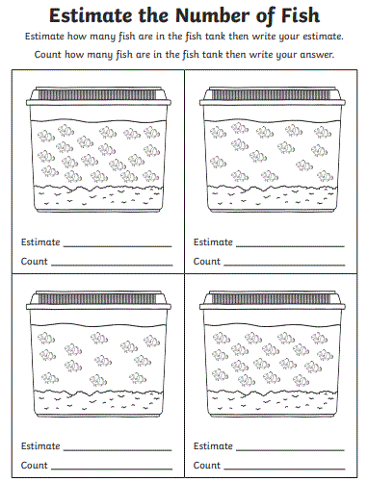

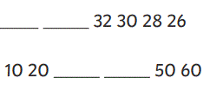**Complete the following sequences:**

1.

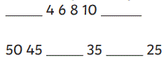2.

3.

4.

**Find the sums of the following:**

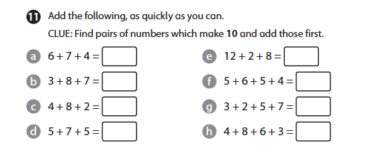

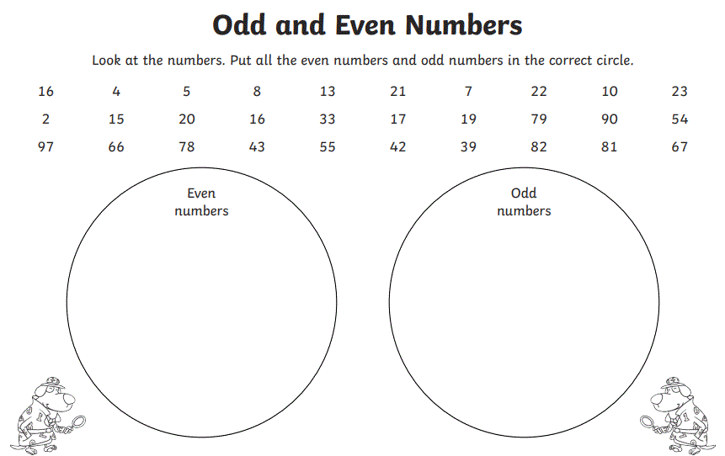

**Part whole model numbers:**

