**Spelling words-week 11**

|  |  |  |  |  |  |  |
| --- | --- | --- | --- | --- | --- | --- |
|  | **Words ending in al** | Sunday | Monday | Tuesday | Wednesday | Thursday |
| 1 | Fouad Mohamed Abou Zikry - Wikipedia**admiral** |  |  |  |  |  |
| 2 | Canal irrigation: types, advantages, disadvantages and design**canal** |  |  |  |  |  |
| 3 | **animal** |  |  |  |  |  |
| 4 | Matter and Materials - Difference Between Solid, Liquid, and Gas**material** |  |  |  |  |  |
| 5 | Download Portal Gate Door Royalty-Free Stock Illustration Image - Pixabay**portal** |  |  |  |  |  |
| 6 | Petal | Definition, Flower, Structure, & Facts | Britannica**petal** |  |  |  |  |  |
| 7 | **metal** |  |  |  |  |  |
| 8 | **festival** |  |  |  |  |  |
| 9 | **pedal** Bicycle pedal - Wikipedia |  |  |  |  |  |
| 10 | **spiral** spiral - Simple English Wiktionary |  |  |  |  |  |

**Choose 5 words and write them in a sentence:**

**1-______________________________________________________________________________________**

**2-_______________________________________________________________________________________**

**3-______________________________________________________________________________________**

**4-______________________________________________________________________________________**

**5-_______________________________________________________________________________________**

**Write the right word for each picture:**

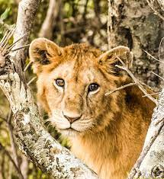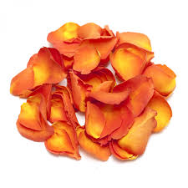

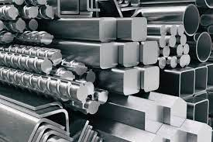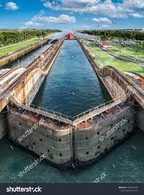 **____________ __________ ______________ ________________**

**Bonus Words**

After that

next