Fish 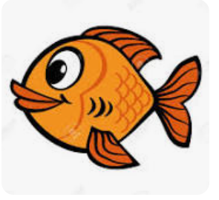

How I wish

I were a -----------!

My day would begin

Flopping my ---------.

I’d made a commotion

Out in the ----------.

It would be cool

To swim in a -----------.

In the sea

I’d move so -----------.

With just one thought,

Don’t get caught.

fish

free

school

ocean

fin