**LO: I can match the words to the meanings of my new words. (CW)**

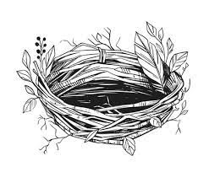  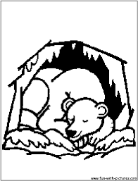 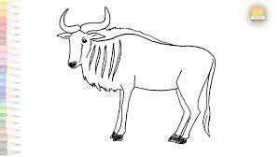

nest claw hibernate wildebeest

Choose the correct word to complete each setence

1. There is a competition between elephants and -----------------
2. *Cuckoos are [famous](https://dictionary.cambridge.org/dictionary/english/famous" \o "famous) for [laying](https://dictionary.cambridge.org/dictionary/english/lay" \o "laying) [their](https://dictionary.cambridge.org/dictionary/english/their" \o "their) [eggs](https://dictionary.cambridge.org/dictionary/english/egg" \o "eggs) in the -------------- of other [birds](https://dictionary.cambridge.org/dictionary/english/bird" \o "birds).*
3. They look like the teeth of some ----------------- animal.
4. *Our [cat](https://dictionary.cambridge.org/dictionary/english/cat" \o "cat) [likes](https://dictionary.cambridge.org/dictionary/english/likes" \o "likes) to****[sharpen](https://dictionary.cambridge.org/dictionary/english/sharpen" \o "sharpen)****her --------------- on the [legs](https://dictionary.cambridge.org/dictionary/english/leg" \o "legs) of the [dining](https://dictionary.cambridge.org/dictionary/english/dine" \o "dining) [table](https://dictionary.cambridge.org/dictionary/english/table" \o "table).*
5. *In the copy books write the following words in a sentence.*

|  |  |  |
| --- | --- | --- |
| *elegant* | *spiky* | *powerful* |