

English



Weekly Pack

Year 2/Term 2

Week 4

# Vocabulary: Idioms and Phrases

# 1. What does the phrase "I am broke" mean?

a. I have plenty of money  
b. I am feeling happy  
c. I have no money  
d. I am feeling tired

### 2. What does the phrase "Pull yourself together" mean?

a. Stand up straight  
b. Take a break  
c. Get organized and focused  
d. Run quickly

### 3. What does the phrase "So far so good" mean?

a. Everything is going wrong  
b. Everything is going well  
c. I am feeling sick  
d. I don't know what to do

### 4. What does the phrase "Light headed" mean?

a. Feeling heavy  
b. Feeling dizzy or faint  
c. Feeling strong  
d. Feeling excited

### 5. What does the phrase "No pain, no gain" mean?

a. Pain makes you gain weight  
b. Pain is unnecessary  
c. You cannot succeed without effort or sacrifice  
d. You should avoid pain at all costs

### 6. What does the phrase "Hang in there" mean?

a. Let go of something  
b. Start again  
c. Stay strong and persevere  
d. Try something new

### 7. What does the phrase "I am broke" mean?

a. I have plenty of money  
b. I am feeling happy  
c. I have no money  
d. I am feeling tired

### 8. What does the phrase "Pull yourself together" mean?

a. Stand up straight  
b. Take a break  
c. Get organized and focused  
d. Run quickly

### 9. What does the phrase "So far so good" mean?

a. Everything is going wrong  
b. Everything is going well  
c. I am feeling sick  
d. I don't know what to do

### 10. What does the phrase "Light headed" mean?

a. Feeling heavy  
b. Feeling dizzy or faint  
c. Feeling strong  
d. Feeling excited

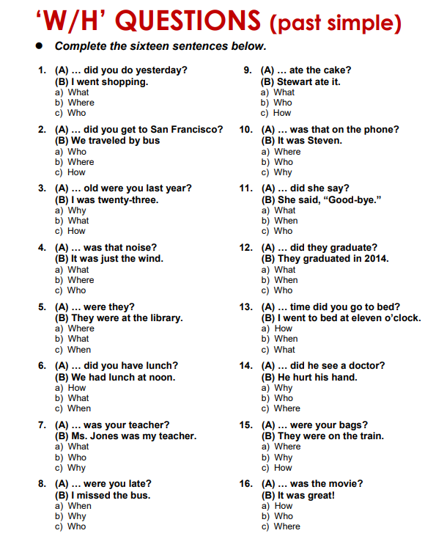

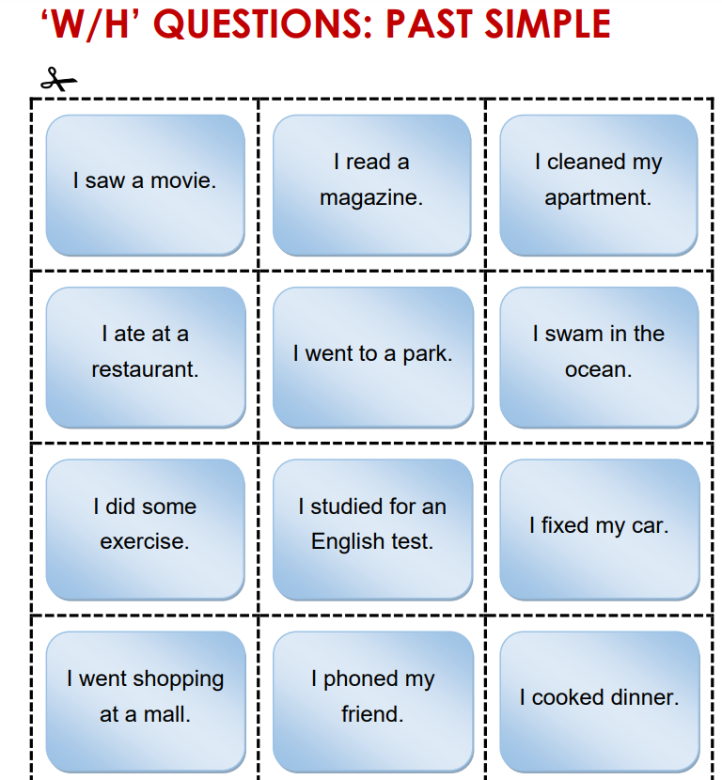

**Write WH questions for these answers:**

**1-_________________________________________________**

**2-_________________________________________________**

**3-_________________________________________________**

**4-_________________________________________________**

**5-_________________________________________________**

**6-_________________________________________________**

**7-_________________________________________________**

**8-_________________________________________________**

**9-_________________________________________________**

**10-________________________________________________**

**11-________________________________________________**

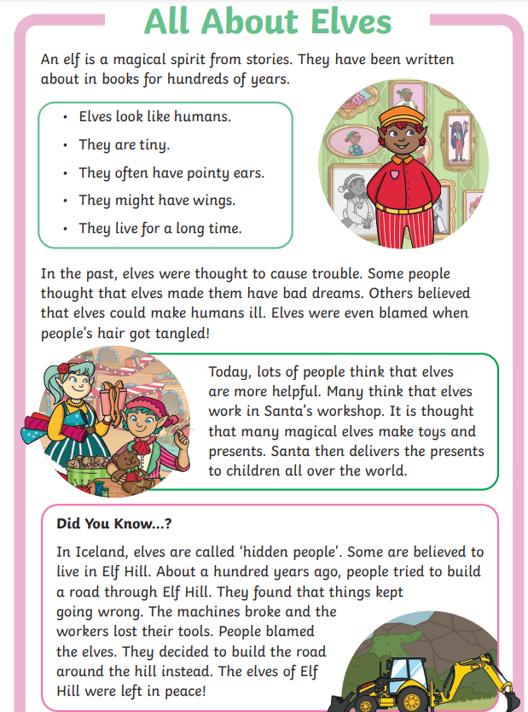

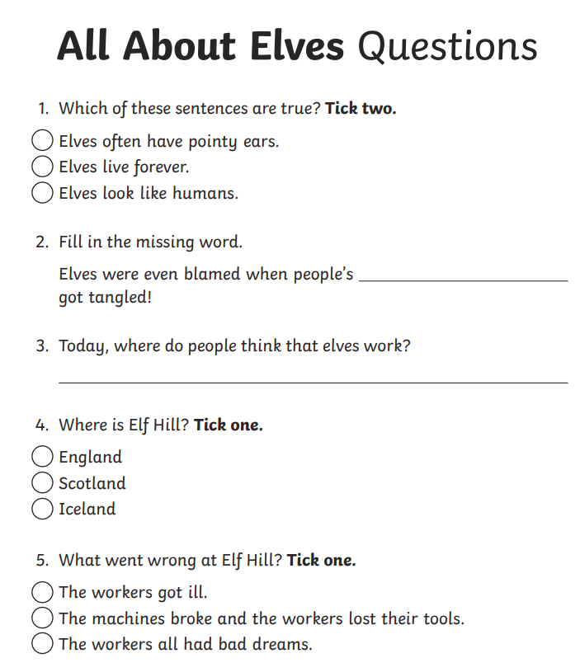6. **Find from the text:**

**Past tense: ___________________**

**Present tense: ________________**

**Adverb: _________________**

**Adjective: _________________**

**Noun: __________________**

**A synonym for the word “small”: ___________________**

**An antonym for the word “right”: ____________________**

7.About a hundred years ago, people tried to build a road for elves.

Write a question for this answer: ___________________________________________________

8.What is the main idea of the text?

___________________________________________________

9-Write a sentence from the text that means that elves were bad people that had bad effects on them.

___________________________________________________

10-people blamed elves.

What is another word or synonym for the word blamed?

_______________________________