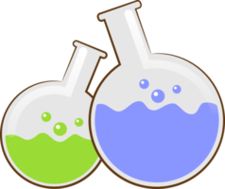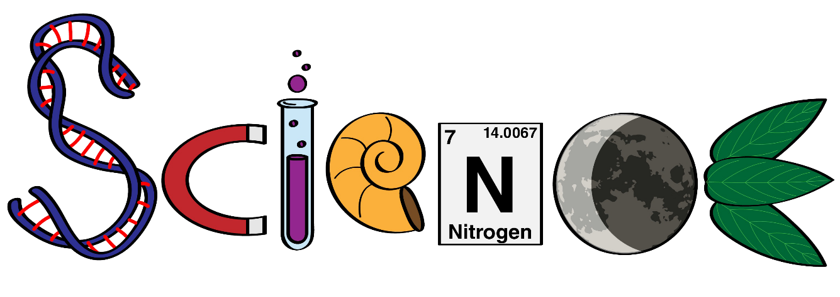

**Name: ………………………………………………….**

**Class: ……………………………………………………**



**Science Department**

**2023/2024**

**Year 1**

**Term 3, Week 6**

**Homework**

The Planet Earth

**Complete:**

1. What is the name of the planet we live on? ………………………………………………

2. What covers most of the Earth's surface? ……………………………………………….

3. True or False: The Earth is the only planet in our solar system with water. …………………….

4. True or False: Mountains are tall and made of water. ………………………………….

5. What gives us light and warmth during the day?.........................

6. True or False: Sunlight is always hot……………………..

7. True or False: The sun rises in the west and sets in the east………………….

8. What are rocks made of?........................................

9. True or False: Rocks can change over time……………………………………

10. True or False: Rocks are always cold to touch…………………………………..

**Multiple Choice:**

11. What is the layer of gases surrounding the Earth called?

a) Atmosphere b) Hydrosphere c) Lithosphere

12. Which of the following is not found on Earth's surface?

a) Rocks b) Sand c) Stars

13. Where can rocks are found?

a) Only on mountains b) Only in rivers c) All around us

14. What living organisms are found in soil?

a) Plants b) Animals c) Bacteria and fungi

15. Why is soil important for plants?

a) It provides support b) It holds water and nutrients

c) It provides sunlight