**Spelling Words Term 2 – Week 11 (HW)**

**Term1 – Week 5**

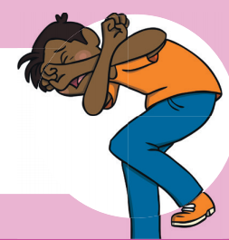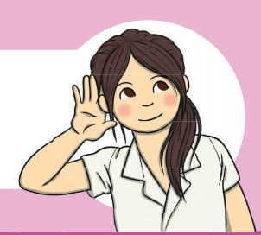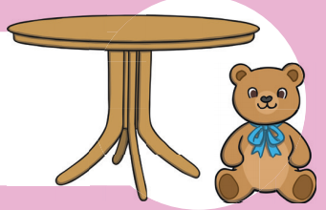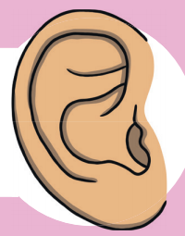

|  |  |  |  |  |  |  |
| --- | --- | --- | --- | --- | --- | --- |
|  | **Words with**  **‘ear’ Sound** | Sunday | Monday | Tuesday | Wednesday | Thursday |
| 1 | beard |  |  |  |  |  |
| 2 | ear |  |  |  |  |  |
| 3 | near |  |  |  |  |  |
| 4 | tear |  |  |  |  |  |
| 5 | hear |  |  |  |  |  |
| 6 | rear |  |  |  |  |  |
| 7 | dear |  |  |  |  |  |
| 8 | fear |  |  |  |  |  |

Wednesday and Thursday write the words in alphabetical order.

**1-______________________________________________________________________________________**

**2-_______________________________________________________________________________________**

**3-______________________________________________________________________________________**

**4-______________________________________________________________________________________**

**5-_______________________________________________________________________________________**

**Write the correct word to complete the sentences:**

|  |  |  |  |  |
| --- | --- | --- | --- | --- |
| Year | earrings | beard | ear | near |

1. My mum puts -------------------- in her ------------------.
2. Happy Chinese New --------------!
3. My dad had a long --------------------- on his face.
4. The school is -------------- my house.

/ear/ sound CW

