Writing Task

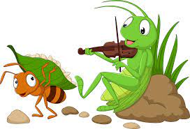

LO: I can write about my story using adverbs

Remember to use:

1-Punctuation

2-Adjectives

3-Connectives

4-speech marks

5-Adverbs ( happily- luckily- gladly- quietly- powerfully)

Writing Task



LO: I can write about my story using adverbs

Remember to use:

1-Punctuation

2-Adjectives

3-Connectives

4-speech marks

5-Adverbs ( happily- luckily- gladly- quietly- powerfully)

If you were in charge of the whole world, what would you do to make the world a happier place?

-Write 3 paragraphs about how you could change the world around you to make it better.

**Remember to use:**

1-Punctuation

2-Adjectives

3-Connectives

4-speech marks (“ and “)

5-Adverbs (happily- luckily- gladly- quietly- powerfully)

If you were in charge of the whole world, what would you do to make the world a happier place?

-Write 3 paragraphs about how you could change the world around you to make it better.

**Remember to use:**

1-Punctuation

2-Adjectives

3-Connectives

4-speech marks (“ and “)

5-Adverbs (happily- luckily- gladly- quietly- powerfully)