**Spelling Words Term1 – Term 2/week 5**

**Term1 – Week 5**

|  |  |  |  |  |  |  |
| --- | --- | --- | --- | --- | --- | --- |
|  | **The ee sound spelt ey** | Sunday | Monday | Tuesday | Wednesday | Thursday |
| 1 | monkey |  |  |  |  |  |
| 2 | journey |  |  |  |  |  |
| 3 | chimney |  |  |  |  |  |
| 4 | key |  |  |  |  |  |
| 5 | donkey |  |  |  |  |  |
| 6 | trolley |  |  |  |  |  |
| 7 | valley |  |  |  |  |  |
| 8 | Chutney  Cilantro Chutney - Spice Cravings |  |  |  |  |  |
| 9 | Pulley  Pulley: Definition, Types, Examples and Diagrams |  |  |  |  |  |
| 10 | Alley  Cortlandt Alley - Wikipedia |  |  |  |  |  |
| 11 | jockeyHorse racing-Champion jockey Dettori says he will retire after 2023 season  | Reuters |  |  |  |  |  |
| 12 | money |  |  |  |  |  |

1. Monkey Which of the following is most closely related to "monkey"?

a) Banana b) Apple c) Orange d) Grape

1. Chutney What is often made with fruits, vinegar, and spices, and is commonly served as a condiment?

a) Chutney b) Ketchup c) Mayonnaise d) Mustard

1. Journey Which word means a long trip from one place to another?

a) Journey b) Vacation c) Picnic d) Nap

1. Trolley What is a type of transportation system that runs on tracks and is often found in urban areas?

a) Bus b) Train c) Trolley d) Bicycle

1. Valley Which geographical feature is a low area of land between hills or mountains, typically with a river or stream flowing through it?

a) Valley b) Mountain c) road d) hill

1. Key Which object is used to unlock doors or start cars?

a) Pen b) Key c) Coin d) Paperclip

1. Chimney What part of a house is typically used to channel smoke from a fireplace or stove to the outside?

a) Window b) Roof c) Chimney d) Door

1. Donkey Which animal is known for its long ears and stubbornness?

a) Horse b) Cow c) Donkey d) Sheep

1. Pulley What simple machine consists of a wheel with a groove around its circumference and a rope or belt that runs along the groove?

a) Pulley b) Lever c) Screw d) Wedge

1. Jockey What is a person who rides horses in races called?

a) Rider b) Jockey c) Cowboy d) Driver

1. Money What is used as a medium of exchange for goods and services?

a) Money b) Time c) Energy d) Love

1. Alley Which word typically refers to a narrow passageway between or behind buildings?

a) Street b) Alley c) street d) Avenue

**English**

**Year 2**

**Pop-up quiz/ term 2/ week 5**

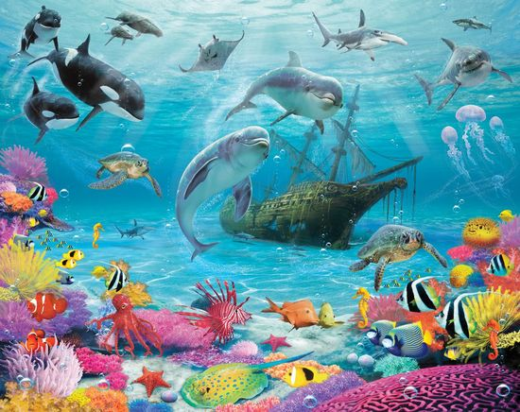

**Describe what you can see in the picture using**

**1-punctuation**

**2-connectives**

**3-Adjectives**

**4-adverbs**

______________________________________________________________________________________________________

______________________________________________________________________________________________________

______________________________________________________________________________________________________

______________________________________________________________________________________________________

______________________________________________________________________________________________________

______________________________________________________________________________________________________

______________________________________________________________________________________________________

______________________________________________________________________________________________________

______________________________________________________________________________________________________

______________________________________________________________________________________________________

______________________________________________________________________________________________________

______________________________________________________________________________________________________

______________________________________________________________________________________________________

______________________________________________________________________________________________________

______________________________________________________________________________________________________

______________________________________________________________________________________________________

______________________________________________________________________________________________________

______________________________________________________________________________________________________

______________________________________________________________________________________________________

______________________________________________________________________________________________________

______________________________________________________________________________________________________

______________________________________________________________________________________________________

# Rubric for Writing Assignment: Begin to write for a purpose using basic language and features appropriate for the text type using adverbs, punctuation and adjectives.

| **Criteria** | **5 Points** | **4 Points** | **3 Points** | **2 Points** | **1 Point** |
| --- | --- | --- | --- | --- | --- |
| Use of adverbs, punctuation, and adjectives | Adverbs, punctuation, and adjectives are consistently and effectively used to enhance the writing. | Adverbs, punctuation, and adjectives are mostly used to enhance the writing. | Adverbs, punctuation, and adjectives are sometimes used to enhance the writing. | Adverbs, punctuation, and adjectives are rarely used to enhance the writing. | Adverbs, punctuation, and adjectives are not used to enhance the writing. |
| Purpose | The writing clearly demonstrates a purpose and effectively conveys the intended message. | The writing mostly demonstrates a purpose and conveys the intended message. | The writing sometimes demonstrates a purpose and partially conveys the intended message. | The writing has a weak sense of purpose and struggles to convey the intended message. | The writing lacks a clear purpose and does not convey the intended message. |
| Language | The language used is varied, appropriate for the text type, and effectively engages the reader. | The language used is mostly appropriate for the text type and engages the reader. | The language used is sometimes appropriate for the text type, but lacks engagement. | The language used is limited and does not effectively capture the reader's attention. | The language used is inappropriate and does not engage the reader. |

**Read the text and highlight the following words:**

**nimble- ferocious- graceful- vicious- feisty- cautious**

In the big forest, there was a nimble squirrel named Sammy. He was very quick and moved with grace, jumping from branch to branch. One day, Sammy saw a ferocious bear lumbering through the trees, its big paws making loud thumps. Sammy knew the bear could be vicious if it felt threatened. But Sammy was feisty and clever. Instead of running away, he stayed cautious, hiding behind a tree and watching the bear quietly until it wandered off. Sammy felt proud of being so smart and quick on his feet!

1. Who is the main character in the story?

________________________________________________________________________________________________

1. What is the name of the nimble squirrel?

________________________________________________________________________________________________

1. What animal did Sammy encounter in the forest?

________________________________________________________________________________________________

1. How did Sammy react when he saw the bear?

________________________________________________________________________________________________

1. Why did Sammy choose to hide behind a tree?

________________________________________________________________________________________________