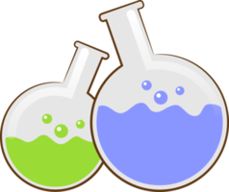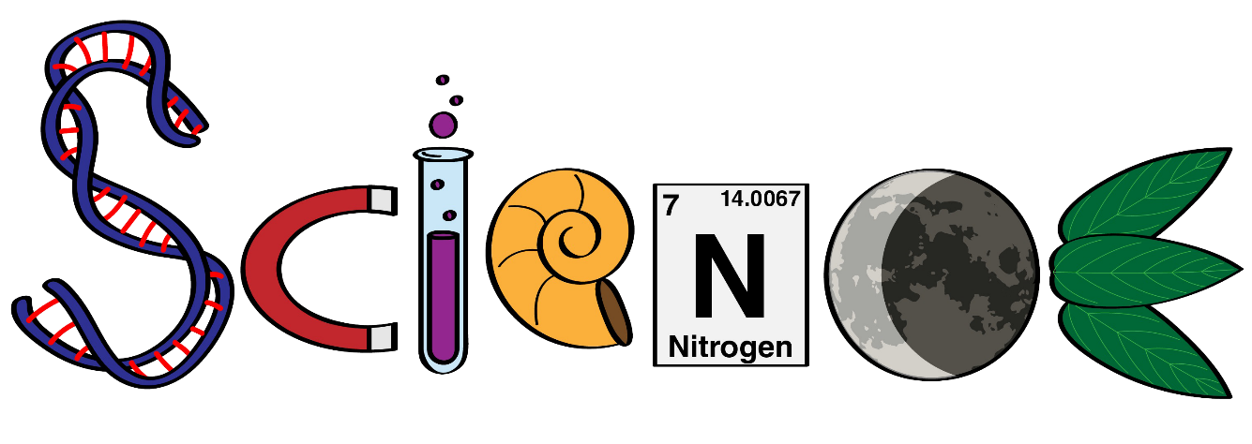

**Name: ………………………………………………….**

**Class: ……………………………………………………**

**Science Department**

**2023/2024**

**Year 4**

**Term 2, Week 6**

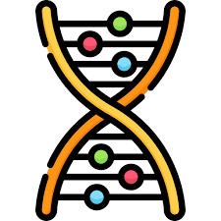

**5.1 + 5.2 + 5.3 Worksheets**

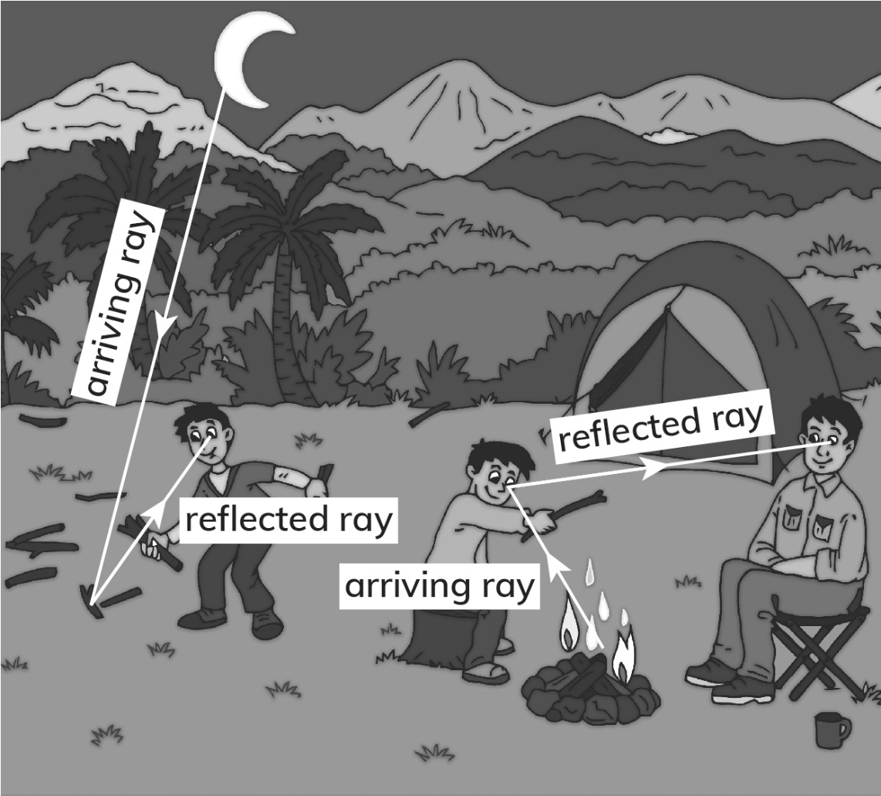1

a- Carlos has gone to collect wood for the fire. Identify the light source.

------------------------------**The moon**------------------------------------------------- .

b- On the picture draw rays to show how Carlos sees the wood. Show the direction of the rays with arrows. Label the arriving ray and the reflected ray.

c- Sergio and his father are sitting facing each other. Identify the light source that allows the father to see Sergio.

------------------------------------------**The fire**----------------------------------------- .

d- On the picture draw rays to show how the father sees Sergio. Show the direction of the rays with arrows. Label the arriving ray and the reflected ray.

2) Define

a- Reflect:

-----------**When light bouncing off a surface** --------------------------------------- .

b- Proof:

----------- **Scientific evidence that something is true** ---------------------------- .

c- Ray:

------------ **A line that light travels in** -------------------------------------------------- .

3) Look at the picture showing Rachel finding her cat.

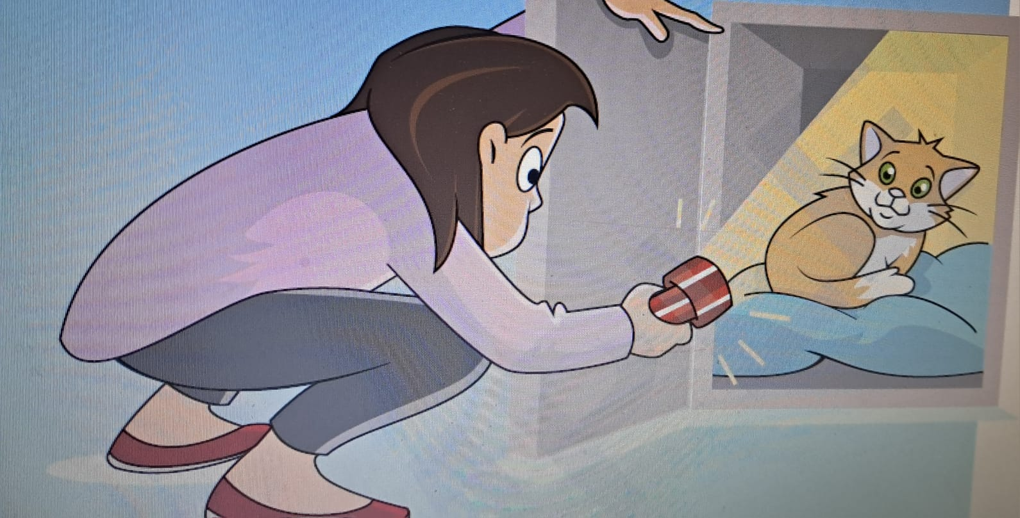

a- Identify the light source.

---------------**The torch / Flashlight**-------------------------------------------- .

b- Identify the object.

------------------**The cat**----------------------------------------------------------- .

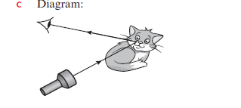

c- Draw a simple ray diagram to show how Rachel sees the cat.

4) Chen rides his bicycle at night.

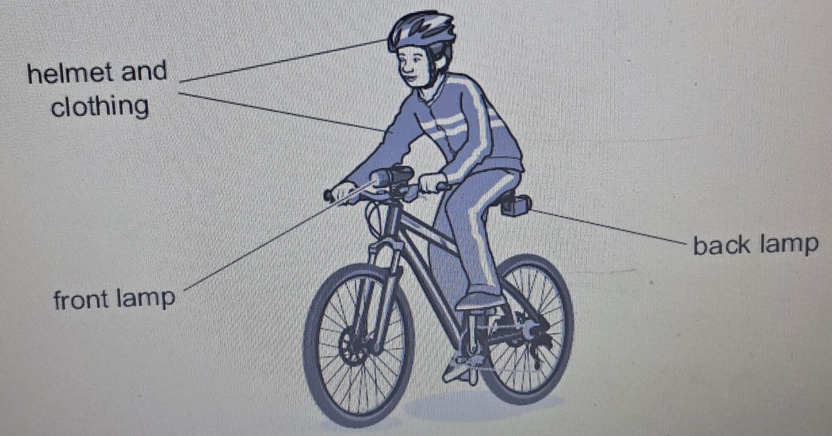

A person driving a car at night can see the front lamp, helmet and clothing.

a-The front lamp is a source of light.

Complete the sentence.

Light from the lamp travels in ……**straight**……. lines to the person.

b-The helmet and clothing are **not** sources of light.

The person in the car sees these clearly.

Explain why.

-----**light from the car is reflected off the helmet and clothing**------------------- .

5) Carlos draws a diagram of his science investigation.

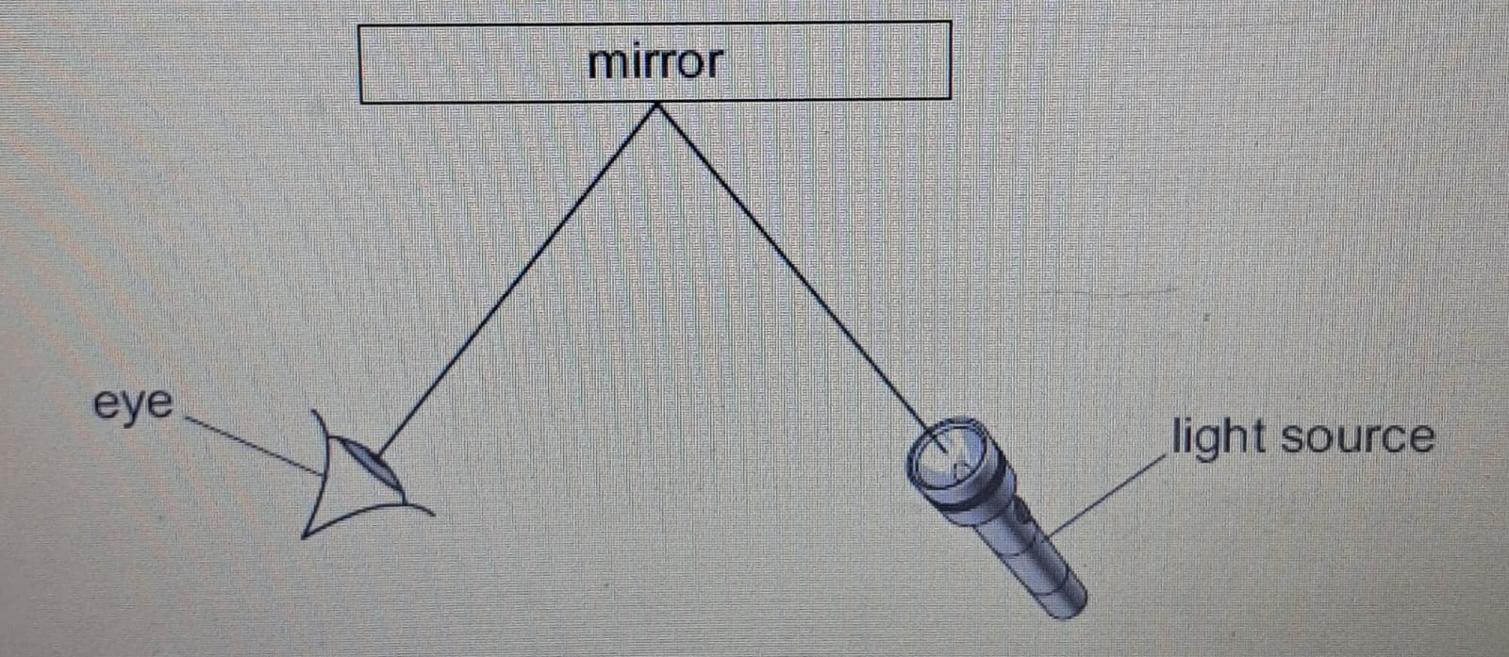

a-Draw **two** arrows on the diagram to show the direction light travels.

b- Complete these sentences about light.

Light travels in ……**straight**……. lines.

When light reaches the mirror the light changes direction because it is …………**reflected**……… .

c- What type of diagram has Carlos drawn?

Circle the correct answer.

**Energy diagram**

**Light diagram**

**Mirror diagram**

**Ray diagram**

4) Fill in ‘better than’ or ‘worse than’ to complete these sentences.

a A mirror reflects light _______**better than**______ any other surface.

b A sheet of brown paper reflects light _______**worse than**______ a sheet of aluminium foil.

