**Spelling Words Term 2 – Week 8 (HW 1)**

**Term1 – Week 5**

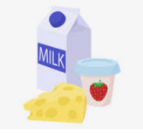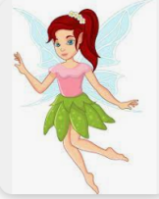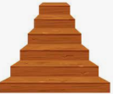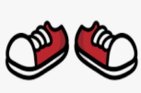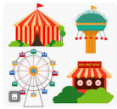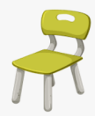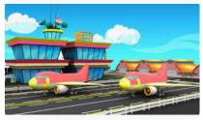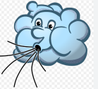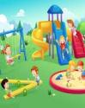\

|  |  |  |  |  |  |  |
| --- | --- | --- | --- | --- | --- | --- |
|  | **Words with**  **‘air’ Sound** | Sunday | Monday | Tuesday | Wednesday | Thursday |
| 1 | air |  |  |  |  |  |
| 2 | airport |  |  |  |  |  |
| 3 | chair |  |  |  |  |  |
| 4 | hair |  |  |  |  |  |
| 5 | fair |  |  |  |  |  |
| 6 | pair |  |  |  |  |  |
| 7 | stair |  |  |  |  |  |
| 8 | fairy |  |  |  |  |  |
| 9 | dairy |  |  |  |  |  |
| 10 | hairy |  |  |  |  |  |

Wednesday and Thursday write the words in alphabetical order.

**Choose 5 words and write them in a sentence: (HW 2)**

**1-______________________________________________________________________________________**

**2-_______________________________________________________________________________________**

**3-______________________________________________________________________________________**

**4-______________________________________________________________________________________**

**5-_______________________________________________________________________________________**

**Fill in the missing words**

|  |  |  |  |
| --- | --- | --- | --- |
| **chair** | **air** | **fairy** | **hair** |

1. She sat on her -------------------.
2. I brush my ---------------- .
3. The plane is up in the ---------------- .
4. I saw the tooth ------------------ on my bed.