**Spelling Words Term 2 – Week 10 (HW)**

**Term1 – Week 5**

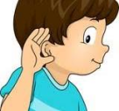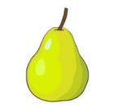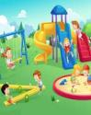

|  |  |  |  |  |  |  |
| --- | --- | --- | --- | --- | --- | --- |
|  | **Words with**  **‘ear’ Sound** | Sunday | Monday | Tuesday | Wednesday | Thursday |
| 1 | pear |  |  |  |  |  |
| 2 | bear |  |  |  |  |  |
| 3 | wear |  |  |  |  |  |
| 4 | tear |  |  |  |  |  |
| 5 | heard |  |  |  |  |  |
| 6 | search |  |  |  |  |  |
| 7 | earn |  |  |  |  |  |
| 8 | earth |  |  |  |  |  |

Wednesday and Thursday write the words in alphabetical order.

**Choose 5 words and write them in a sentence: (HW 2)**

**1-______________________________________________________________________________________**

**2-_______________________________________________________________________________________**

**3-______________________________________________________________________________________**

**4-______________________________________________________________________________________**

**5-_______________________________________________________________________________________**