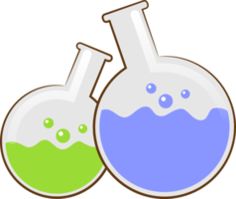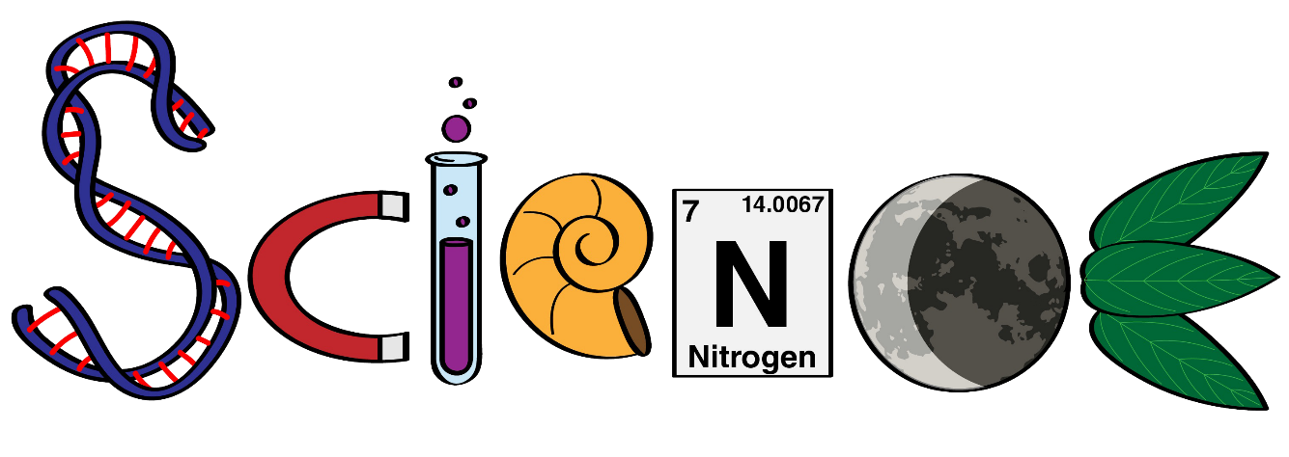

**Name: ………………………………………………….**

**Class: ……………………………………………………**

**Science Department**

**2023/2024**

**Year 1**

**Term 3, Week 6**



The Planet Earth

1. Circle the picture that shows the Earth:

A:  B: 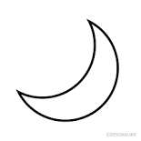 c: 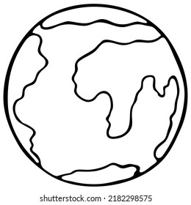

1. What gives us heat and light:

A: Moon B: Starts c: Sun

1. Which Picture shows a rock:

A: 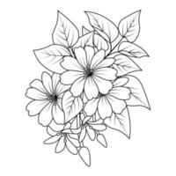 B: 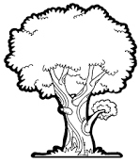 c: 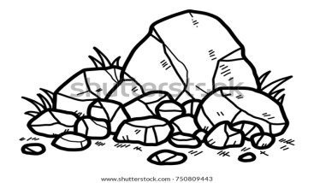

1. Which picture is a soil:

A:  B:  C: 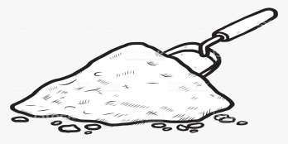

1. Match the picture with its correct term:

**Earth Sun Rock Soil**

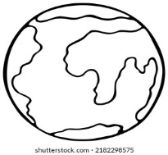

Complete the sentences:

1. The Earth is mostly covered with ………………………………………… .
2. We feel warm when we stand under the ……………………………… .
3. The light and heat that comes from the sun keep the Earth ……….………………&…………………………… .
4. The sun is ……………… that is close to the Earth.
5. The surface of the earth is made from …………….. & …………………. .
6. Soil is made from ………………………..& ………………………………….. .
7. People dig out rocks in a ………………………………….

What is:

1. The name of the plant we live on?
2. The rocks made from?
3. The tiny living organisms in the soil?
4. The main source of energy for plants?
5. The Earth is made from?

True or False:

1. The Earth is flat?
2. The earth in the only planet in the solar system?
3. All the land on Earth is covered with water?
4. People and animals live on Earth?
5. The Earth is a big ball floating in space?