**Dessert Time!**

Yum! It is time for dessert.

First, Tim gets a cookie.

Next, Jan gets some cake.

Then, Ben gets a donut.

Last, Deb gets some pie.

Oh no! There is none left for Sam.

What will he do?

First, Tim shares his cookie.

Next, Jan shares her cake.

Then, Ben shares his donut.

Last, Deb shares her pie.

Yum! Sam and his friends are happy.

It is time for dessert!

**Questions:**

1. What desserts did Tim, Jan, Ben, and Deb each receive initially?

Cookie, cake, donut, pie

1. How did Sam end up getting a dessert in the end?

All his friends shared their dessert with him.

1. How did the sharing of desserts make Sam and his friends feel?

They were happy.

Choose the correct answer

1. What dessert did Jan get?

A) Cookie

B) Cake

C) Donut

D) Pie

2. Who was left without any dessert in the beginning?

A) Tim

B) Jan

C) Ben

D) Sam

1. How did Sam finally get something to eat for dessert?

A) Tim gave him a cookie

B) Jan gave him some cake

C) Ben shared his donut

D) Deb shared her pie

True or False

1. Tim gets a cookie first. (True/False)
2. Sam is left with no dessert at the end. (True/False)
3. Sam and his friends are happy at the end. (True/False)

**Read the following text**

“The children shared their yummy desserts with Sam”.

1. **Find the following from the above text**

**A Noun:** children, desserts, Sam

**A Verb:** Shared

**An Adjective:** yummy

1. Change the following singular **nouns** into **plural** nouns by adding **“s”** or **“es”**

DessertDessertsCake Cakes

Donuts Donuts Pie Pies

1. Choose the correct verb to make it **past tense** adding **“ed”** andwrite it

Jack (paint/painted) a picture. painted

The dog (panted/pant) in the heat. panted

1. Choose the **verb** from the following sentences “**s”** or **“es”** (Simple Present Tense) and write it.

My hat ( match/matches) my gloves! matches

Henry (read/ reads) a lot of books. reads

1. Complete the sentence with the verbs in brackets

Use **Present Continuous** Tense.

John (is/are) is reading (read/reading) a book now.

Jack and Peter (is/are) are working (work/working) late today.

1. Complete the sentences using the correct **comparative** or **superlative** form

Milo is the (cuter/cutest) cutest dog on the street.

Adam is (louder/loudest) louder than Linda in the

classroom.

**Vocabulary**

1. **Write the following words in sentences:**

**Dessert:**

___________________________________________________

__________________________________________________

**Shares:**

**Writing**

**How to make pancakes**

**Label the materials needed:**

|  |  |  |  |
| --- | --- | --- | --- |
| **milk** | **flour** | **whisk** | **egg** |

**What you need:**

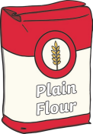 flour

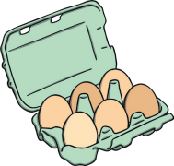 egg

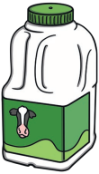 milk

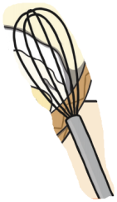 whisk

**Read the instructions. Write them in the correct step.**

|  |
| --- |
| Cook the mixture in a frying pan. |
| Eat and Enjoy! |
| Serve with your favourite toppings. |
| Whisk the flour, egg and milk together in a bowl. |

**Steps to make pancakes:**

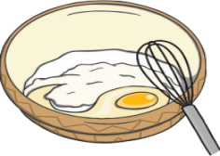 First, Whisk the flour, egg, and milk together in a bowl.

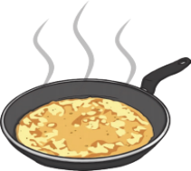 Next, Cook the mixture in a frying pan.

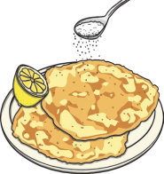 Then, Serve with your favourite toppings.

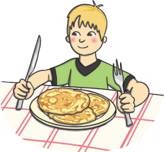 Finally, Eat and Enjoy!

**Peanuts and Popcorn**

John is going to a baseball game with his aunt. He can’t wait to get

there. It is the first game of the season. The stadium is almost full.

He loves to watch baseball, but his favorite part of going to games is

eating the snacks. There are many different snacks at baseball

games. A man in a red hat walks up and down the aisles selling

peanuts and popcorn. Guess which is John’s favorite. John likes them

both. He especially likes mixing peanuts and popcorn together. If he

is really hungry he will have a hot dog.

**Questions**

1. Where is John going? Baseball game.
2. Who is he going with? His aunt.
3. Who sells the peanuts and popcorn? A man in a red hat
4. What does John do with the peanuts and popcorn?

He mixes them together.

**True or False**

1. John's favorite part of going to baseball games is watching the game itself. (True/False)
2. The man in a red hat sells peanuts and popcorn to the fans at the baseball game. (True/False)
3. John enjoys mixing peanuts and popcorn together as a snack option. (True/False)
4. **Read the following text**

**“**A man in a red hat walks up and down the aisles selling

peanuts and popcorn.”

**Find the following from the above text**

**A Noun:** man, hat, aisles, peanuts, popcorn

**A Verb:** walks, selling

**An Adjective:** red

1. Change the following singular **nouns** into **plural** nouns by adding **“s”** or **“es”**

**Season Seasons Stadium Stadiums**

**Base Bases Coach Coaches**

1. Choose the **verb** from the following sentences “**s”** or **“es”** (Simple Present Tense) and write it.

Doris (work/works) works in the hospital everyday.

Mr. Lee and Mrs. Lee (drink/drinks) drink coffee

every morning.

1. Choose the correct verb to make it **past tense** adding **“ed”** andwrite it

A man in a red hat (walks/walked) up and down the aisles. walked

John (watches/watched) the baseball game with his

aunt. watched

1. Complete the sentence with the verbs in brackets

Use **Present Continuous** Tense.

It (is/are) is starting (start/starting) to rain

again.

I (is/am ) am teaching (teach/teaching) him how to

read.

1. Complete the sentences using the correct **comparative** or **superlative** form

Where is the (colder/coldest) coldest place on

Earth?

Cats are (nicer/nicest) nicer than dogs.

**Vocabulary:**

1. **Write the following words in sentences:**

**Season:**

**___________________________________________________**

**Stadium**

**___________________________________________________**

**Writing**

**How to make popcorn**

**Label the materials needed:**

|  |  |  |  |  |
| --- | --- | --- | --- | --- |
| **microwave** | **bowl** | **Popcorn Kernels** | **Popcorn**  **packet** | **salt** |

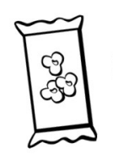 Popcorn Kernels

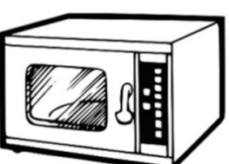 microwave

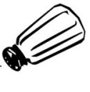 salt

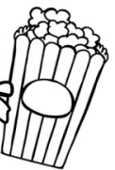_ Popcorn packet

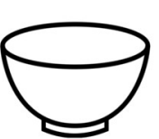 bowl

**Read the instructions. Write them in the correct step.**

|  |
| --- |
| Put the bowl in the microwave. |
| Eat the popcorn and Enjoy it! |
| Pour the popcorn kernels into a bowl. |
| Pour salt onto the popcorn and let it cool. |

**Steps to make popcorn**

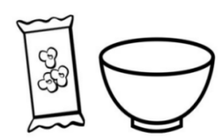 First, Pour the popcorn kernels into a bowl.

__________________________________________________

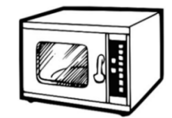 Next, Put the bowl in the microwave.

__________________________________________________

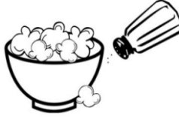 Then, Pour salt onto the popcorn and let it cool.

________________________________________________________

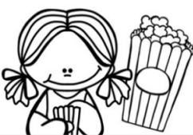 Finally, Eat the popcorn and Enjoy it!

________________________________________________________

**A Visit to the Water Park**

There is a new water park in town. We go there on the first day of

summer. It has pools and water slides. There are sprinklers too.

The slides are scary at first.

After the first ride, we love the water slides. The sprinklers are

cool on hot days.

One of the pools makes its own waves. All the kids try to surf the

waves. It is really fun. The water park can be very crowded.

There are many kids and adults, but they do not allow pets.

We really like the ice cream at the snack bar. They also sell pop and

donuts. We all love the new water park.

Questions:

1. What is new in town?

Water park.

___________________________________________________

1. What is scary at first?

The slides

1. What is cool on a hot day?

The sprinklers

________________________________________________

1. What do they love at the snack bar?

The ice-cream

___________________________________________________

**True or False**

1. (True or False): The water park has pools, water slides, and sprinklers.
2. (True or False): All the kids at the water park are allowed to bring their pets.
3. (True or False): The main snack items sold at the water park are ice cream, pop, and donuts.
4. **Read the following text**

**“**

“There is a new water park in town. We go there on the first day of

summer.”

**Find the following from the above text**

**A Noun:** water park, town, summer

**A Verb:** go

**An Adjective:** new, first

1. Change the following singular **nouns** into **plural** nouns by adding **“s”** or **“es”**

**Ride**  Rides **Pop** Pops

**Water** Waters **Snack** Snacks

1. Choose the **verb** from the following sentences “**s”** or **“es”** (Simple Present Tense) and write it.

Doris (wash/washes) washes her face every night.

Mr. Lee and Mrs. Lee (read/reads) read the

newspaper every afternoon.

1. Choose the correct verb to make it **past tense** adding **“ed”** andwrite it

We really (like/liked) the ice cream at the snack bar. liked

We all (love/loved) the new water park. loved

1. Complete the sentence with the verbs in brackets

Use **Present Continuous** Tense.

It (is/are) is starting (start/starting) to rain

again.

I (is/am ) am teaching (teach/teaching) him how to

read.

1. Complete the sentences using the correct **comparative** or **superlative** form

The pool is (warmer/warmest) than the sea. warmer.

Cheetahs are the (faster/fastest) animals on land. fastest

**Vocabulary:**

1. **Write the following words in sentences:**

**Pool:**

**___________________________________________________**

**Slides:**

**___________________________________________________**

.