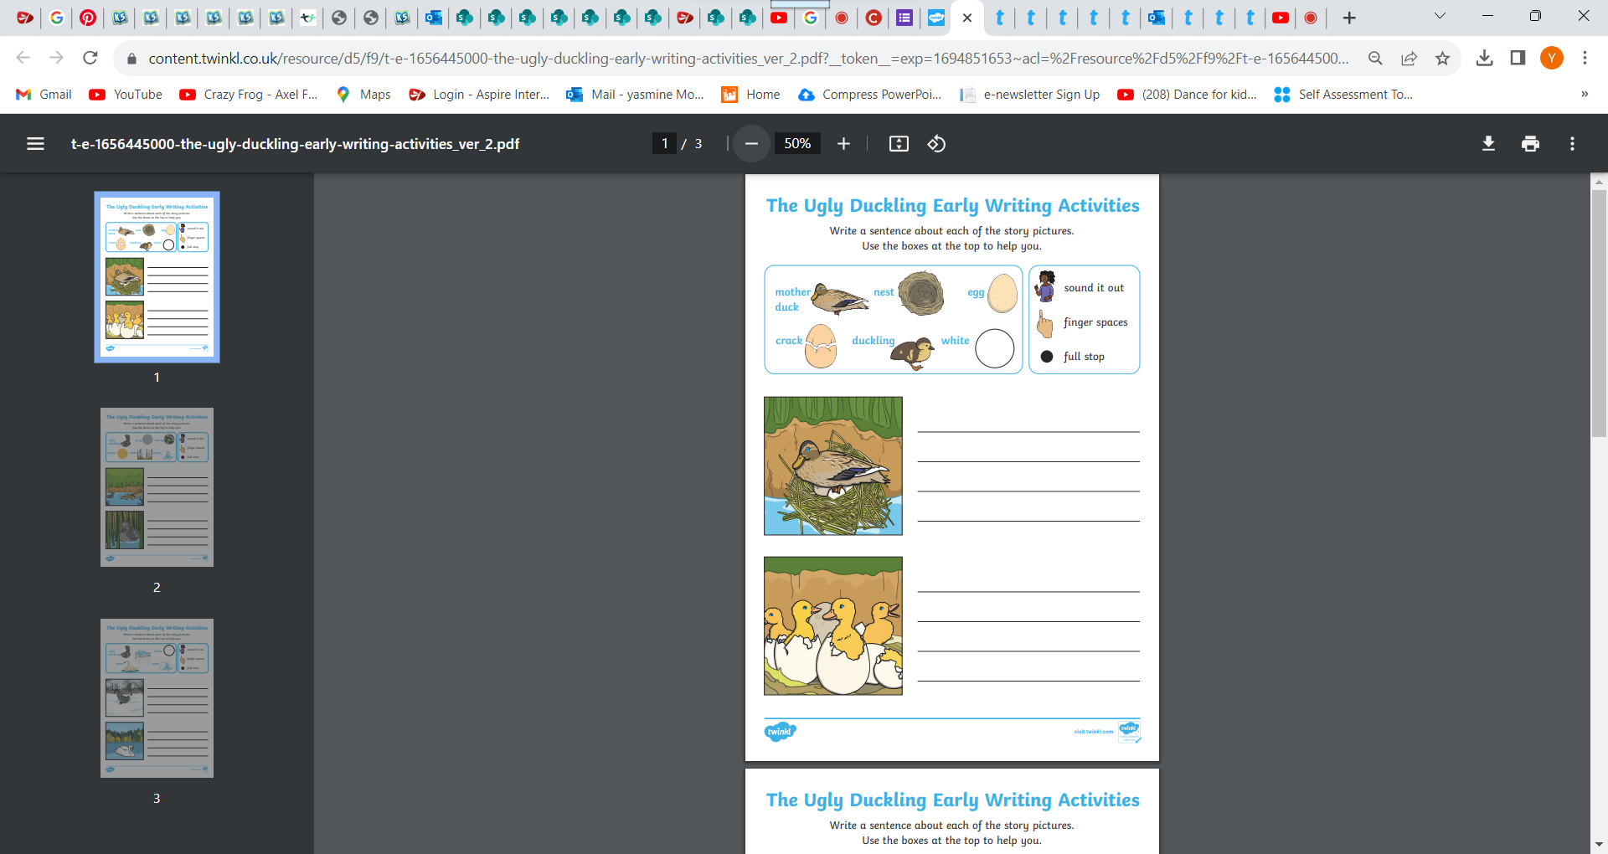

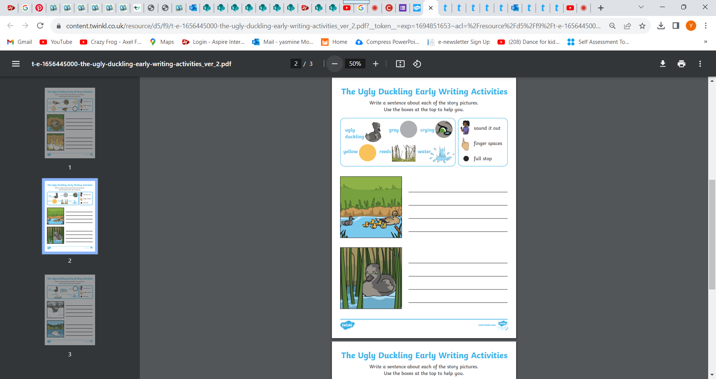

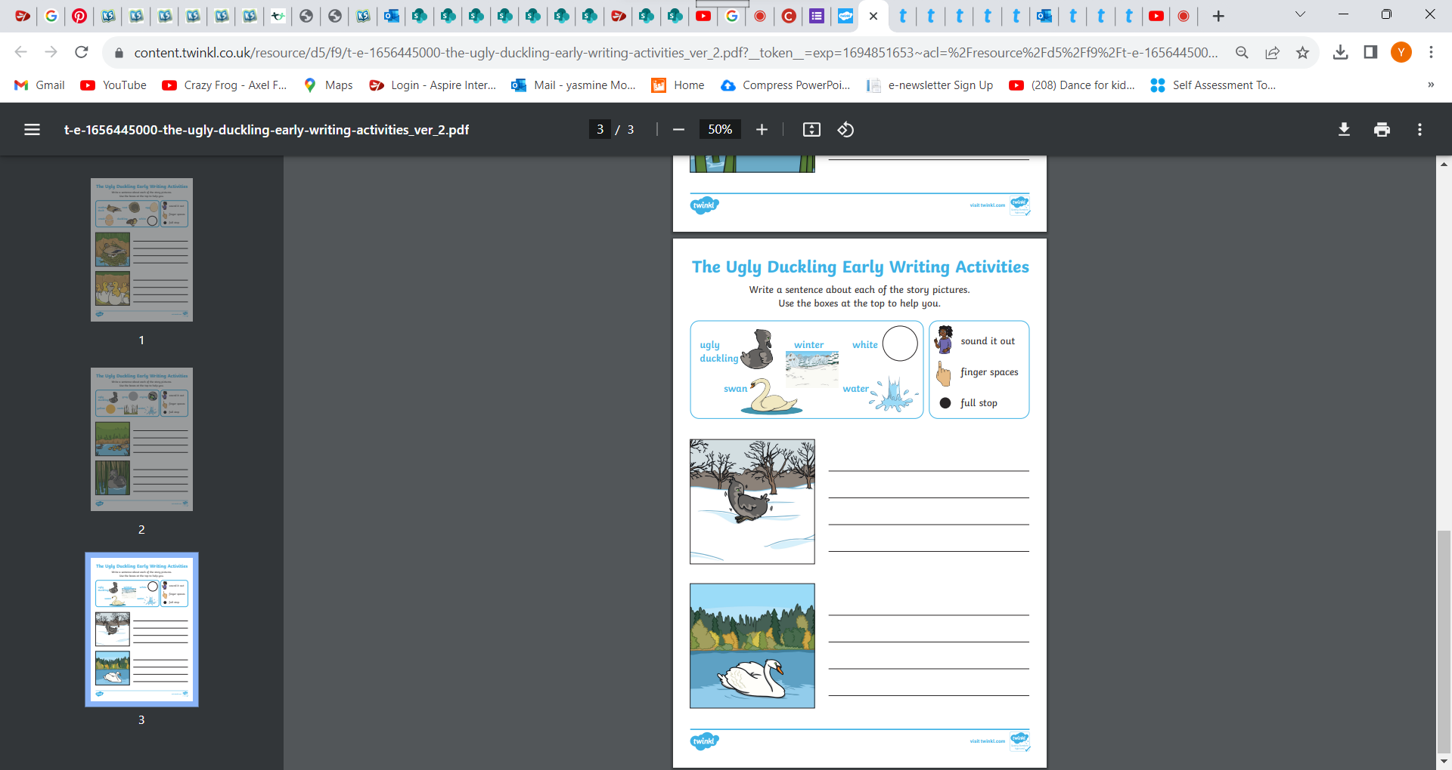

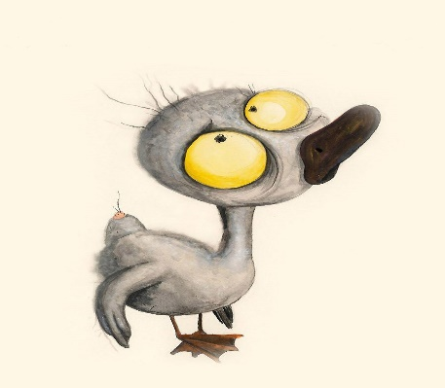**LO: I can write some sentences to describe the ugly duckling and the swan using adjectives from my word bank.**

**Word Bank: ugly- horrible- awful- grey**

___________________________________________________

_____________________________________________________

__________________________________________________________________________________

__________________________________________________________________________________

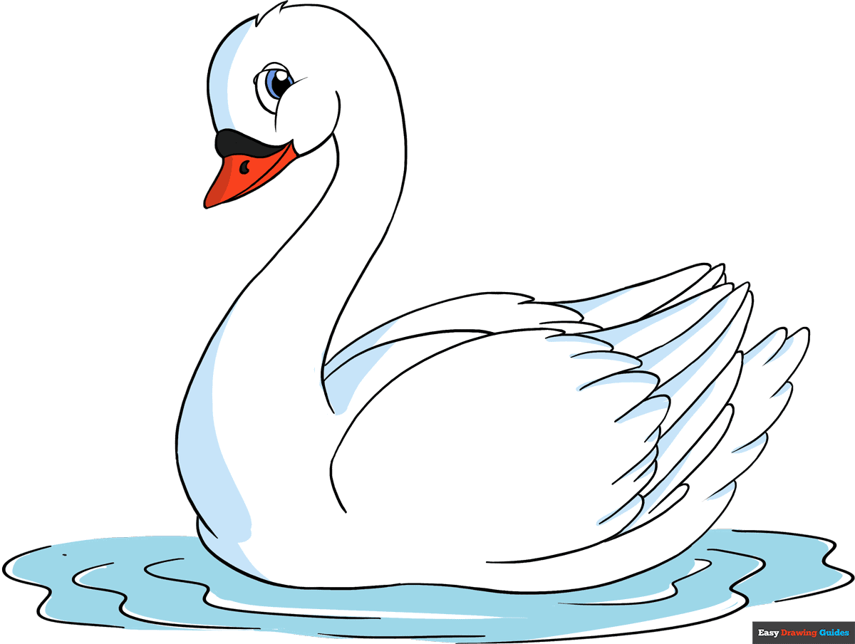**Word Bank: white- beautiful- magnificent- awesome**

___________________________________________________

_____________________________________________________

__________________________________________________________________________________

__________________________________________________________________________________

__________________________________________________________________________________

__________________________________________________________________________________