**Spelling Words Term1 – Week 9**

**Term1 – Week 5**

|  |  |  |  |  |  |  |
| --- | --- | --- | --- | --- | --- | --- |
|  | **Words ending in le-** | Sunday | Monday | Tuesday | Wednesday | Thursday |
| 1 | Cable  Cat6 network cable - 20m: Buy Online at Best Price in Egypt - Souq is now  Amazon.eg |  |  |  |  |  |
| 2 | Wobble Board By Playdale Playgrounds - Made In The UKWobble |  |  |  |  |  |
| 3 | castle |  |  |  |  |  |
| 4 | simple |  |  |  |  |  |
| 5 | circle |  |  |  |  |  |
| 6 | feebleWeak Person Vector Art, Icons, and Graphics for Free Download |  |  |  |  |  |
| 7 | rubbleHow to Get Rid of Rubble | Skips, Reusing And Recycling | Checkatrade |  |  |  |  |  |
| 8 | bobbleSeabirds Woolly Bobble Hat - plain |  |  |  |  |  |
| 9 | Ankle Pain Management | Dr. Scholl'sankle |  |  |  |  |  |
| 10 | Hobble  20+ Hobble Illustrations, Royalty-Free Vector Graphics & Clip Art - iStock  | Hobble skirt |  |  |  |  |  |

**Choose 5 words and write them in a sentence:**

**1-______________________________________________________________________________________**

**2-_______________________________________________________________________________________**

**3-______________________________________________________________________________________**

**4-______________________________________________________________________________________**

**5-_______________________________________________________________________________________**

**Look at the pictures and write the correct word**

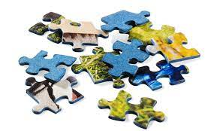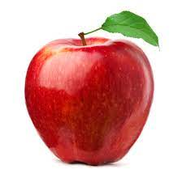



**_______________ _______________ _______________**

**Bonus Words**

because

suddenly