Spelling Words Year 2 Term 1

|  |  |  |
| --- | --- | --- |
|  | Common words | Write a sentence for each word |
| 1 | **put** | My Sentence: |
| 2 | **very** | My Sentence: |
| 3 | **people** | My Sentence: |
| 4 | **called** | My Sentence: |
| 5 | **asked** | My Sentence: |
| 6 | **above** | My Sentence: |
| 7 | **mother** | My Sentence: |
| 8 | **baby** | My Sentence: |
| 9 | **both** | My Sentence: |
| 10 | **knew** | My Sentence: |

**Name:……………………………………. Date: ……………………………..**

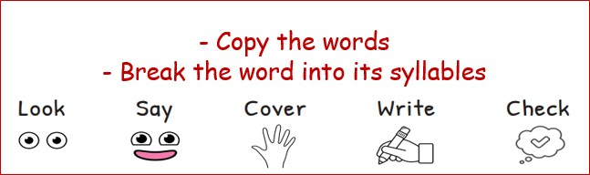

|  |  |  |  |  |
| --- | --- | --- | --- | --- |
| Sunday | Monday | Tuesday | Wednesday | Thursday |
|  |  |  |  |  |
|  |  |  |  |  |
|  |  |  |  |  |
|  |  |  |  |  |
|  |  |  |  |  |
|  |  |  |  |  |
|  |  |  |  |  |
|  |  |  |  |  |
|  |  |  |  |  |
|  |  |  |  |  |

Please practice your spelling words every day for your spelling exam on Sunday. Good luck! :)