**What is Scientific Method?**

The Scientific Methods are steps that scientist use in order to understand how things work and why they work the way they do.

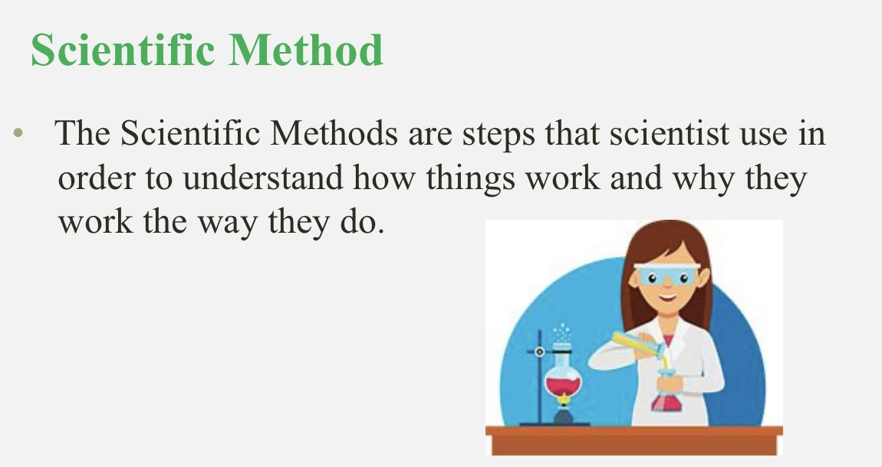

**Living things and non-living things**

Plants make their own food. Animals move around and eat other things.

Plants and animals are alive. They are living things. All things need food. Water moves but it is not alive.

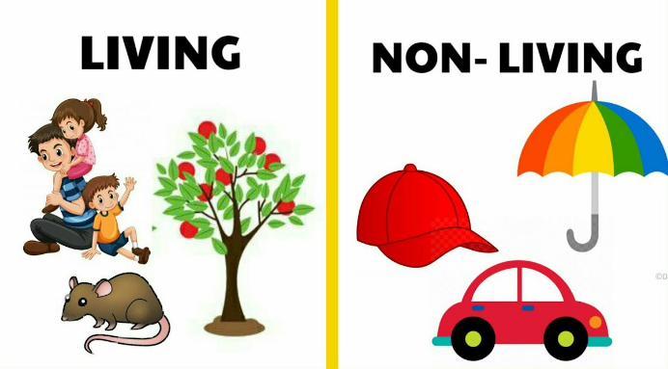

**Parts of a plant**

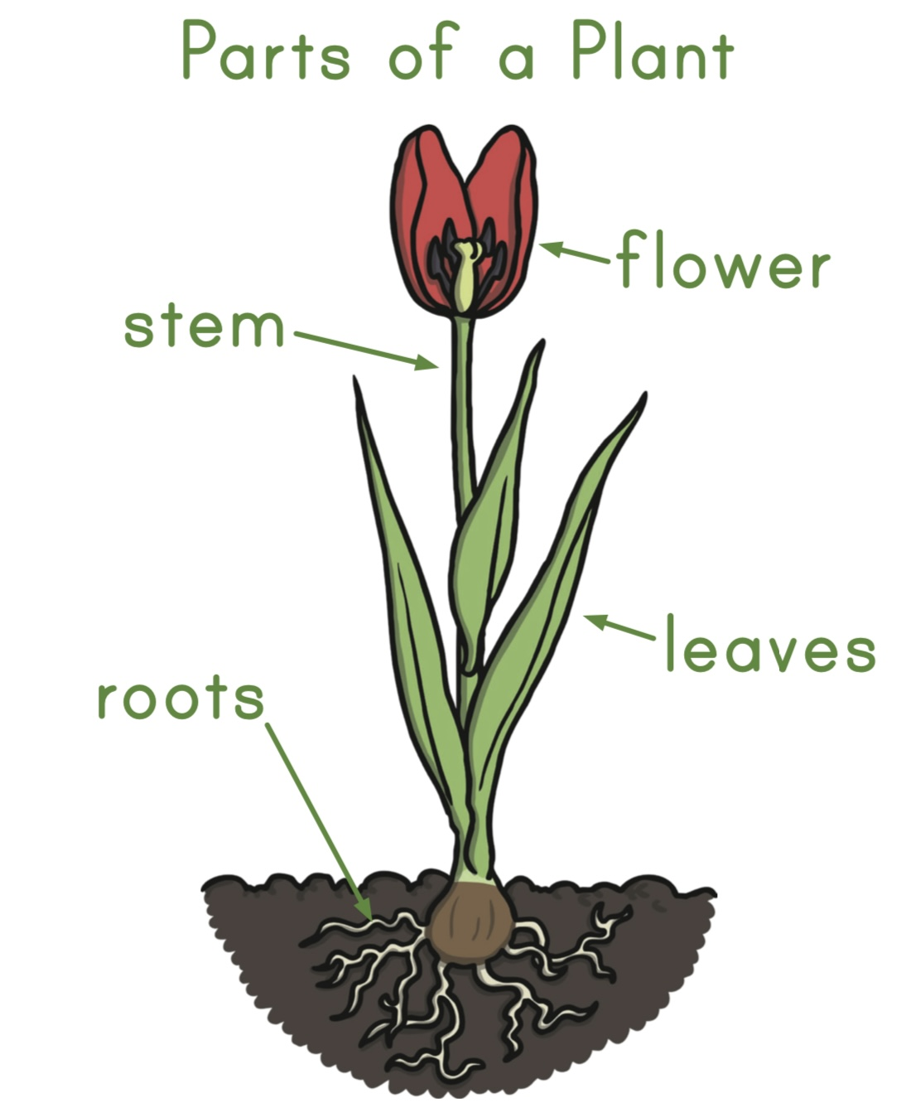

**What plant needs for growth**

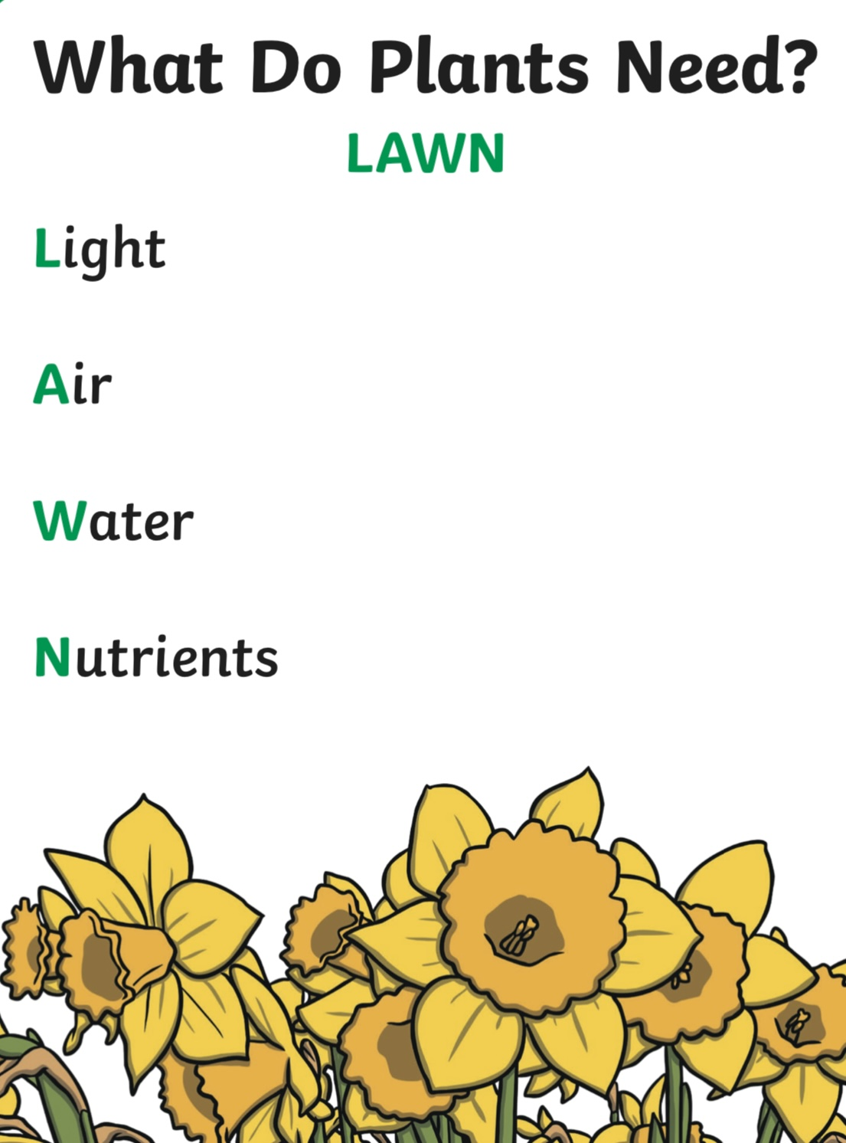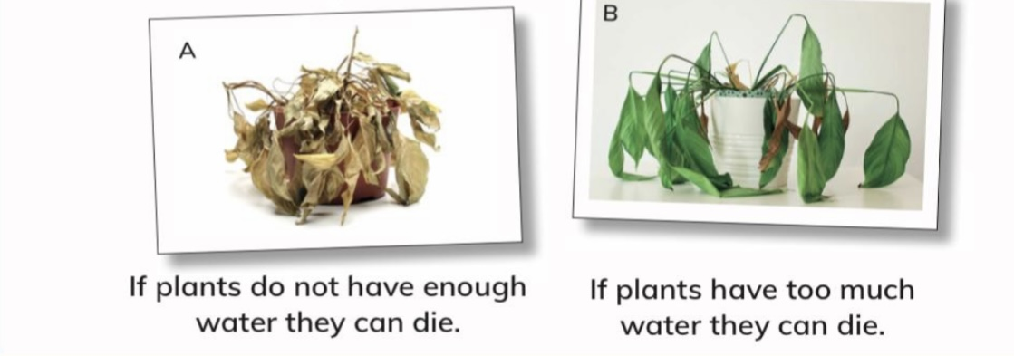

**Functions of a plant**

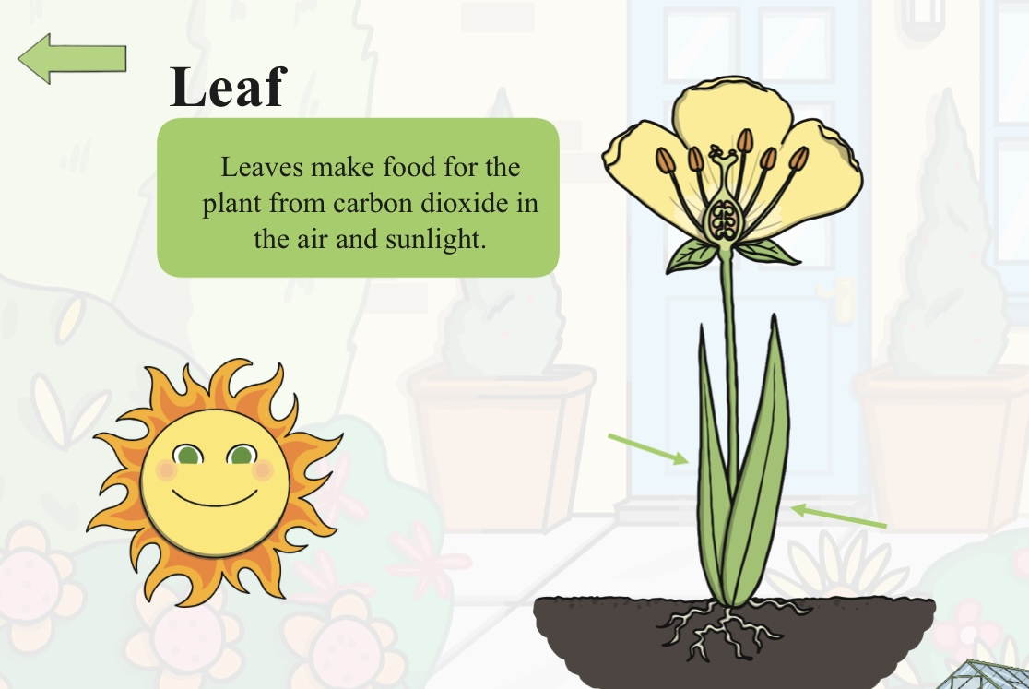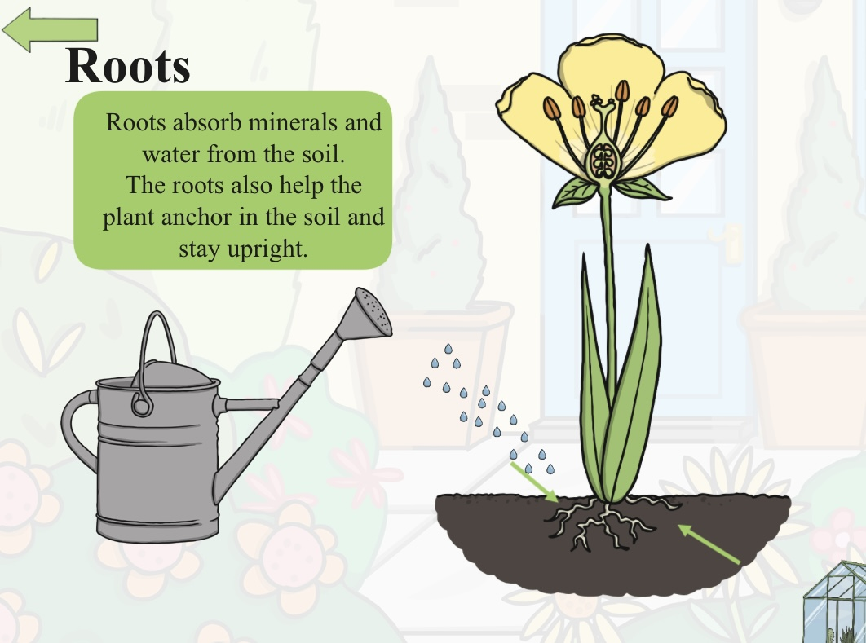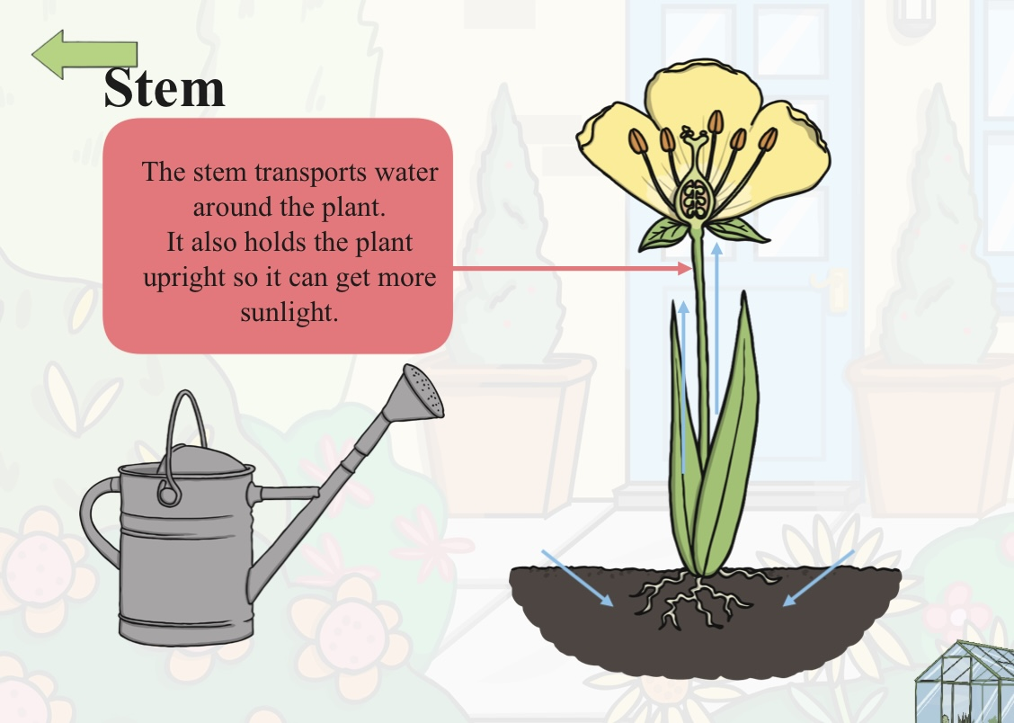

**Sound**

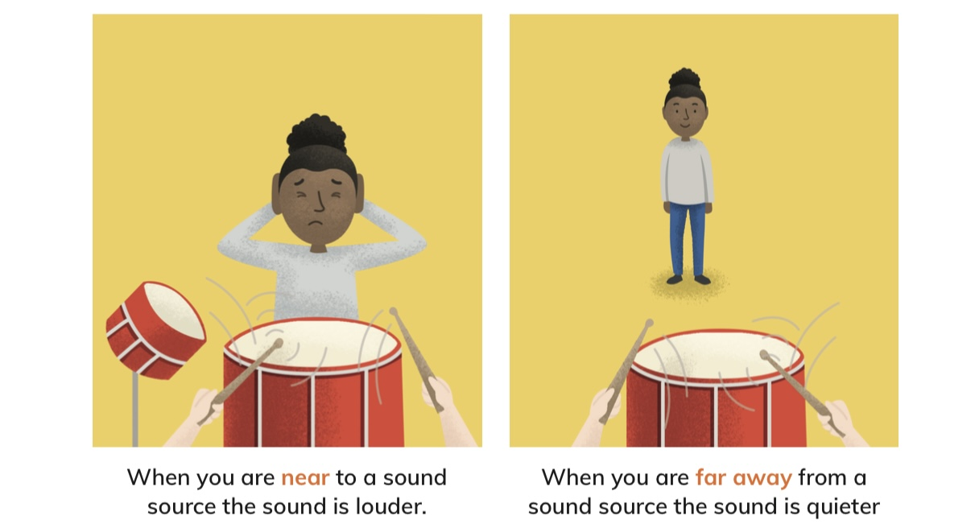

**Sound source**

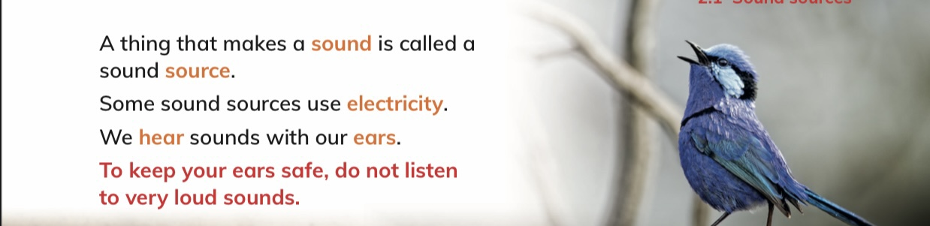

**Loud and quiet sounds**

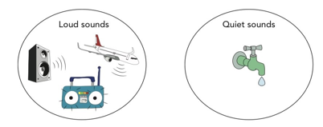

**Sound moves**

Sounds move away from a sound source. We hear the sound when it gets to our ears. We call this listening.

**Materials in my world**

Everything around us is made from material. Objects might be made from**:**

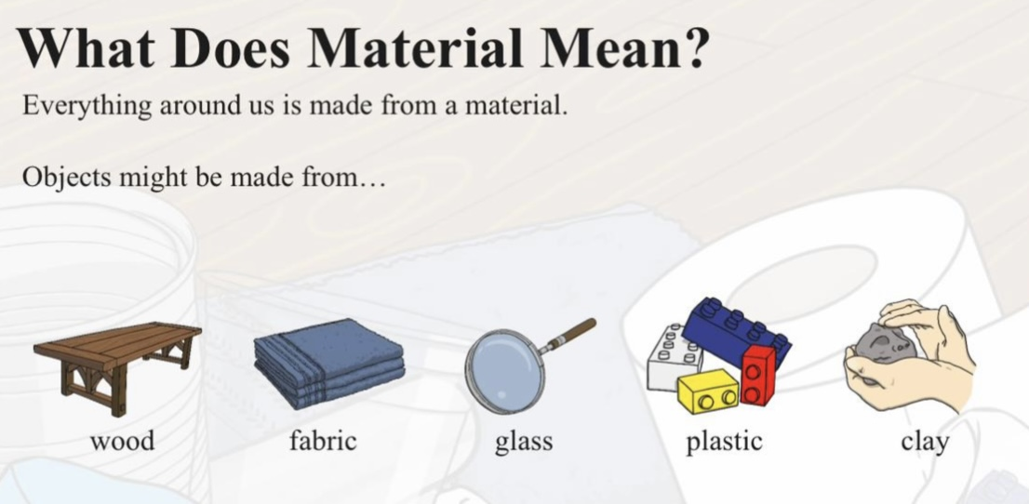

**Properties of materials**   
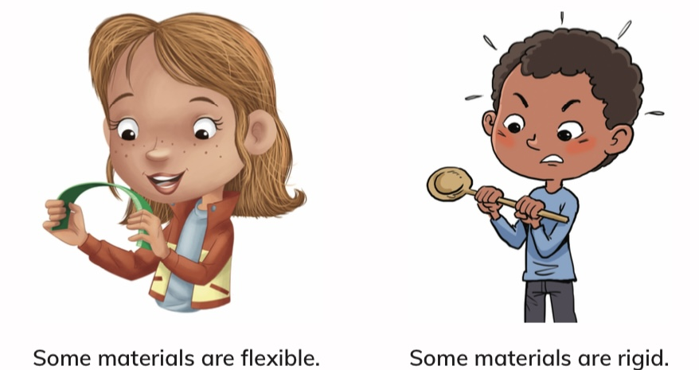

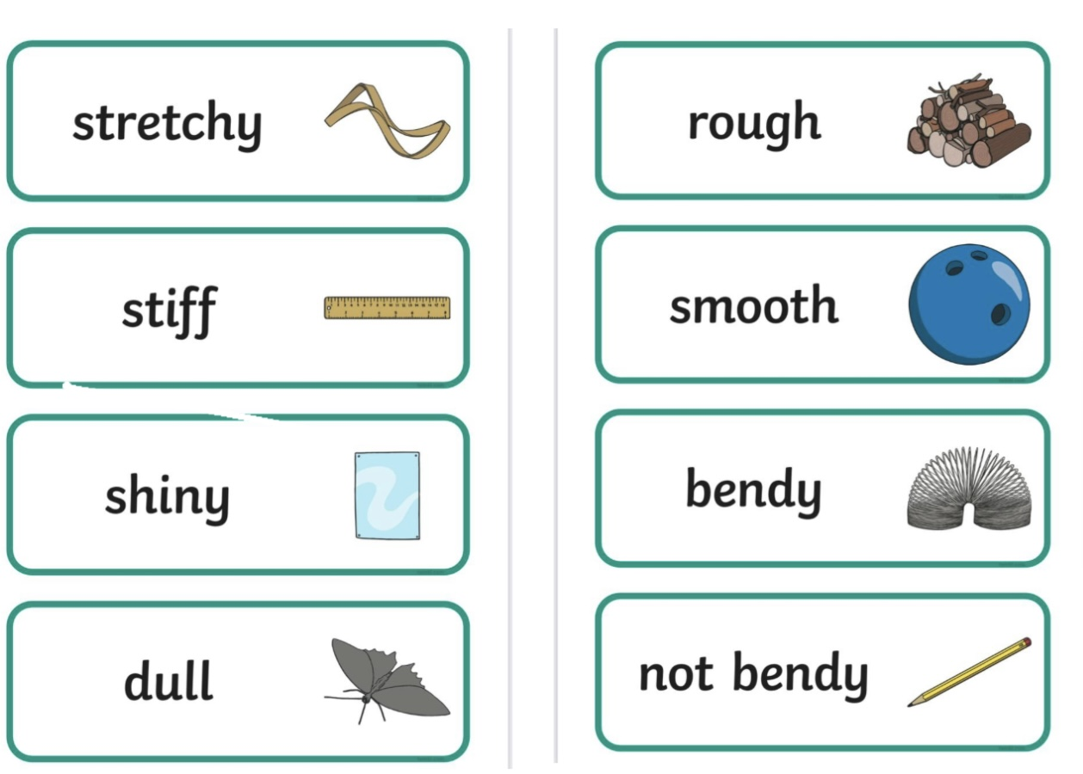

**Changing materials**

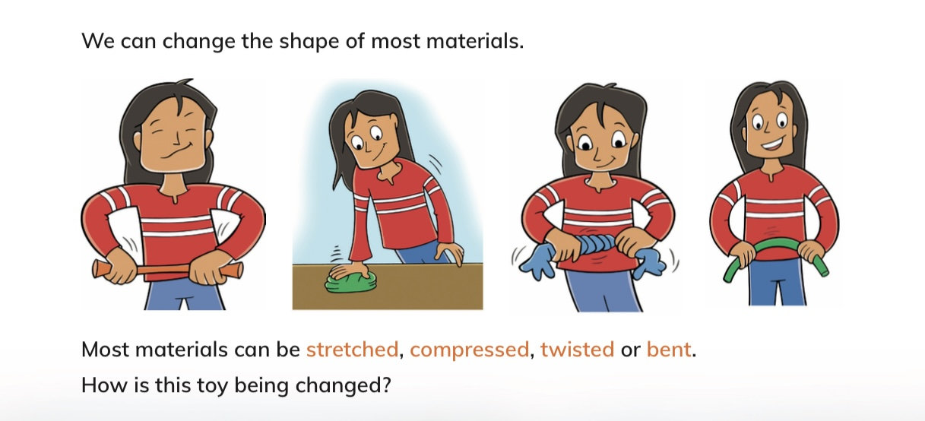 **Soil**

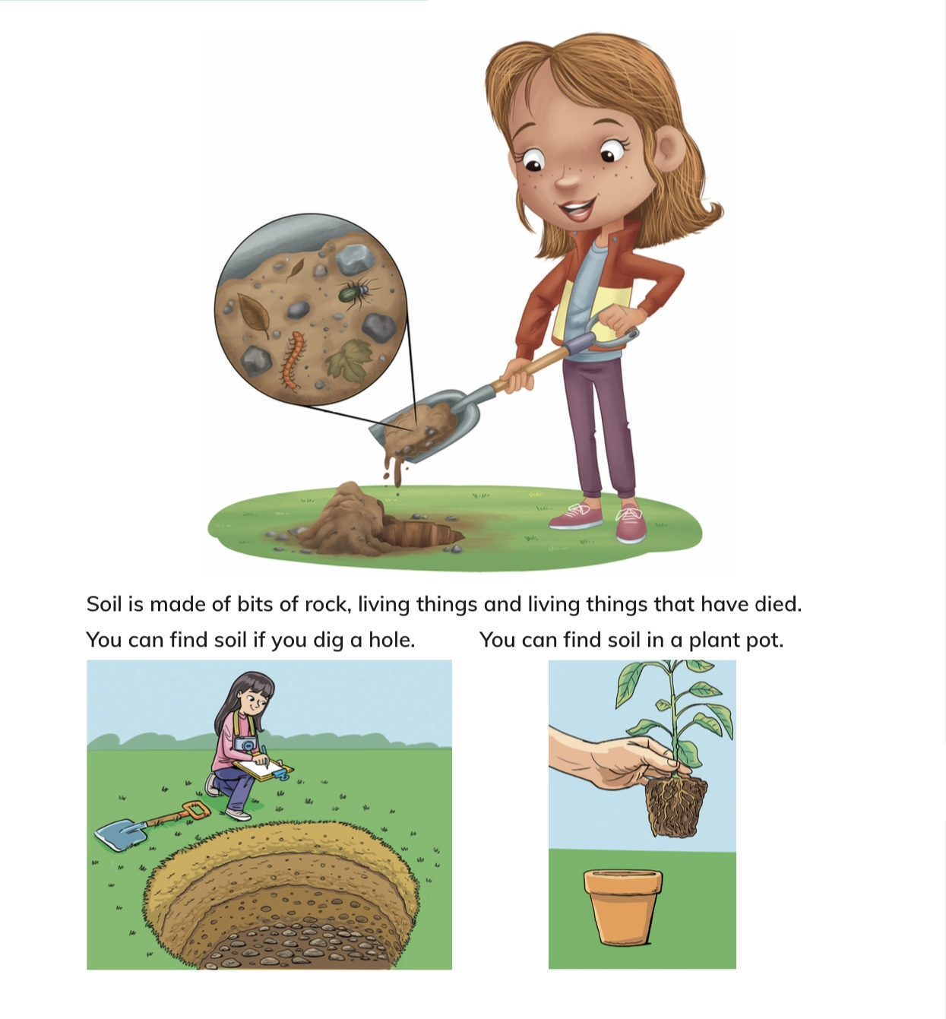

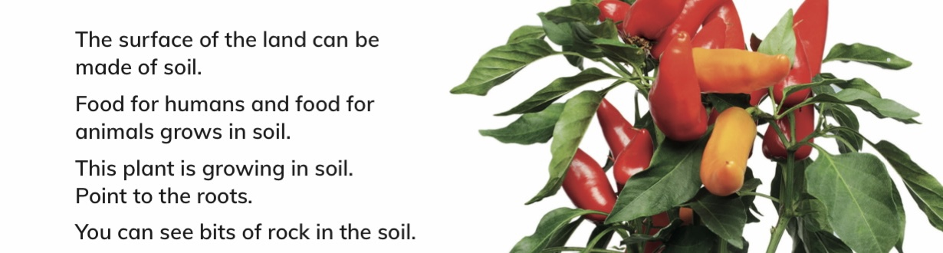

**Earth**

The planet we live on is called Earth. When we recycle materials we can use them again. When we recycle we make less waste.

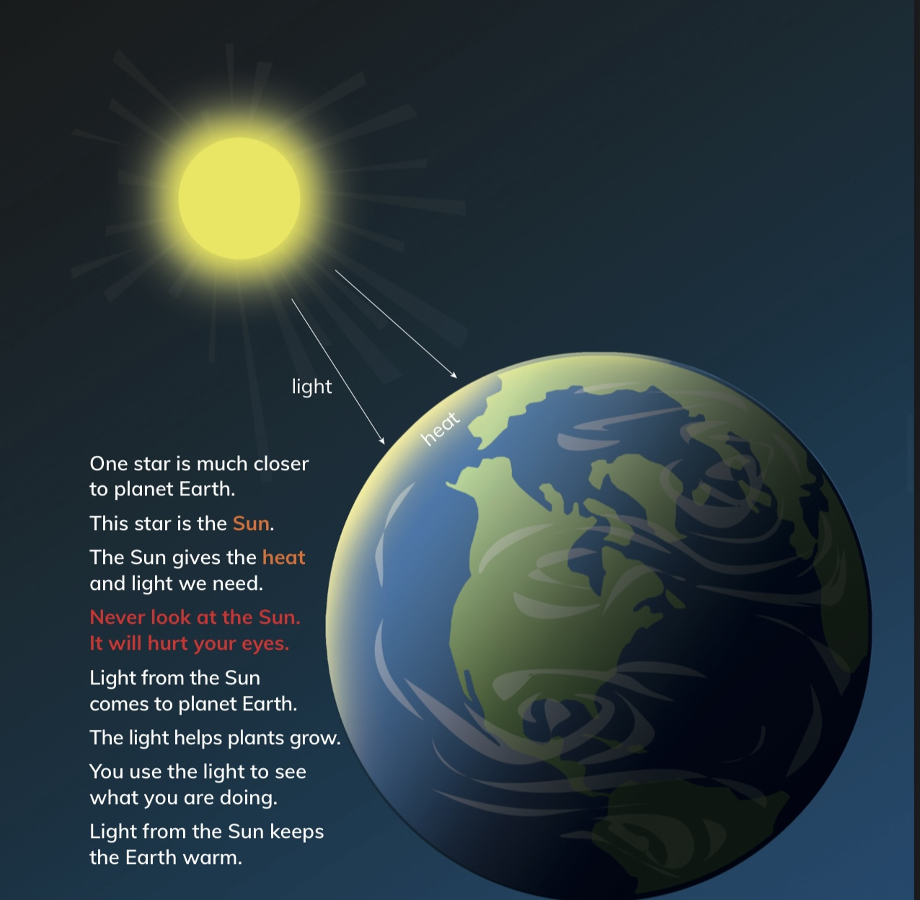

Some parts of the surface of Earth are dry land, but some parts are covered by water. You live on planet Earth. You live on the dry land. You make your home on the dry land. Planet Earth is very big. It is shaped like a ball.

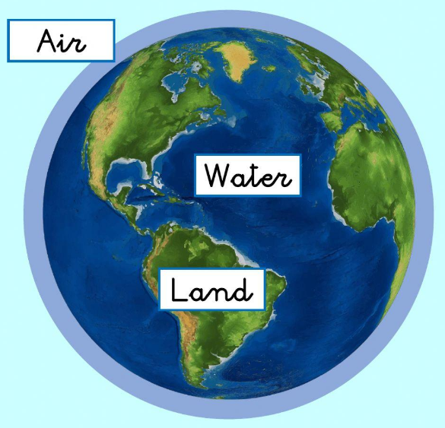

**Why do we need the Sun’s heat?**

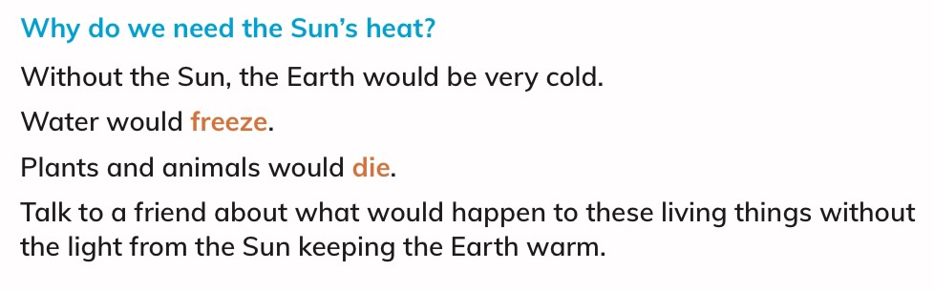

**Rocks**

Some rocks are very big and some are very small. Stones are small rocks. Sand is made of very small pieces of rock. Many rocks are deep beneath the surface of the Earth. People dig out rocks in a place called a quarry. They use tools and diggers to get the rocks.

