**Grammar Day 3 Thursday 7/12/2023**

1. **Conjunctions (and, but, or)**

**And: to combine two same ideas.**

**I went to the store and bought apples and bananas.**

**But: to combine two opposite ideas**

**I wanted to buy egss but I didn’t have enough money**

**Or: To choose between two or more ideas.**

**Would you like to read or watch TV**

**Fill in the blanks with**

|  |  |  |
| --- | --- | --- |
| **and** | **or** | **but** |

1. **Is this pen yours ------------ mine?**
2. **The dog took the bone ----------- buried it.**
3. **He likes the red dog --------- not the blue one.**
4. **Mark sat on the sofa ---------- slept off.**
5. **Do you like milk --------- tea?**
6. **You must hurry --------- you will be late.**
7. **Susan likes to sing --------- dance.**
8. **This dog is small --------- brave.**
9. **Please pass me a spoon ----------- a fork.**
10. **I like sunshine ------------ not the rain.**

**Choose the correct conjunctions to complete the sentences.**

1. **Do you want to go to the park--------- the library**
2. **But b. or**
3. **I have a pet fish ---------- a pet turtle**
4. **But b. and**
5. **We went swimming ----------- fishing today**
6. **And b. but**
7. **Do you like summer --------- winter more?**
8. **But b. or**
9. **Put the cheese in the tin --------- cover it with a lid.**
10. **Or b. and**
11. **I wanted to call you last night --------- my brother**

**was on the phone.**

1. **Or b. but**
2. **I got ready ---------- went to school.**

1. **But b. and**
2. **Emily loves spelling, --------- doesn’t like art much.**

1. **But b. or**
2. **They went to the forest ------------- there they**

**saw a big cave.**

1. **Or b. and**
2. **We packed a picnic, ------------ then it rained so**

**we didn’t go.**

1. **But b. and**

**Buillding Sentences**

**Sentences are made when words are put together in the correct order.**

**A sentence sarts with a capital letter and ends with a full stop.**

**Put the words in order to make a sentence.**

1. 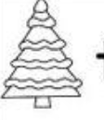 **tree green see I a**

---------------------------------------------------------------------------------------------------------------------------------------

1. 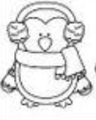  **cold is penguin This**

---------------------------------------------------------------------------------------------------------------------------------------

1. 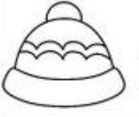  **purple I hat a have**

---------------------------------------------------------------------------------------------------------------------------------------

1. 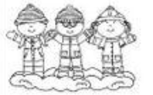  **see kids three I**

---------------------------------------------------------------------------------------------------------------------------------------

1. 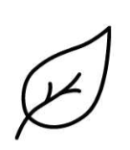 **pretty The leaves are**

---------------------------------------------------------------------------------------------------------------------------------------

1.  **playing is football He**

---------------------------------------------------------------------------------------------------------------------------------------

1.  **heavy is This very box a**

---------------------------------------------------------------------------------------------------------------------------------------

1.  **read to books I like**

---------------------------------------------------------------------------------------------------------------------------------------

1. 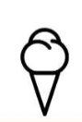  **cold is This ice-cream**

---------------------------------------------------------------------------------------------------------------------------------------

1.   **four Nina has pencils**

---------------------------------------------------------------------------------------------------------------------------------------