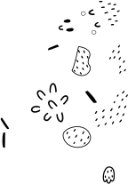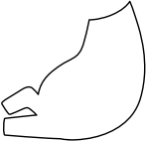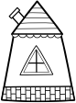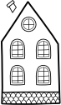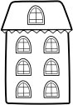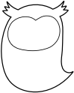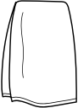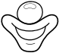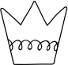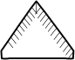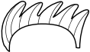

U

**ow digraph worksheet**

**(CW 1)**

Sound the digraph and write the digraph to complete the word.

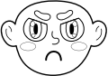

fl__er

fr__n

t__n

c__



d__n

cr__n

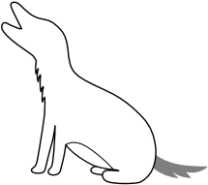







…

cl__n t__el __l h__l

**/ow/ Sound Matching (CW 2)**

|  |
| --- |
|  |
|  |
|  |
|  |
|  |
|  |
|  |
|  |
|  |
|  |

**=**

**=**

**=**

**=**

**=**

**=**

**=**

**=**

**=**

**=**

Read the ‘ow’ words carefully, match them to the correct picture and then write each word, next to the picture.

|  |
| --- |
| **cow** |
| **frown** |
| **owl** |
| **gown** |
| **crown** |
| **town** |
| **bow** |
| **clown** |
| **growl** |
| **howl** |